LEAHY, JAMES.

Company Serjeant Major
A Coy, 2nd Bn. Royal Munster Fusiliers
Date of Death: 25/09/1915 Aged 26.
Service No: 8580

Birthplace: St. Patrick's, Cork, June 1889
Enlisted: Kinsale, Co. Cork on 10th September 1906 aged 17 years and 4 months.
Address given as 4 South Douglas Rd, Cork.

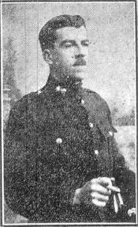

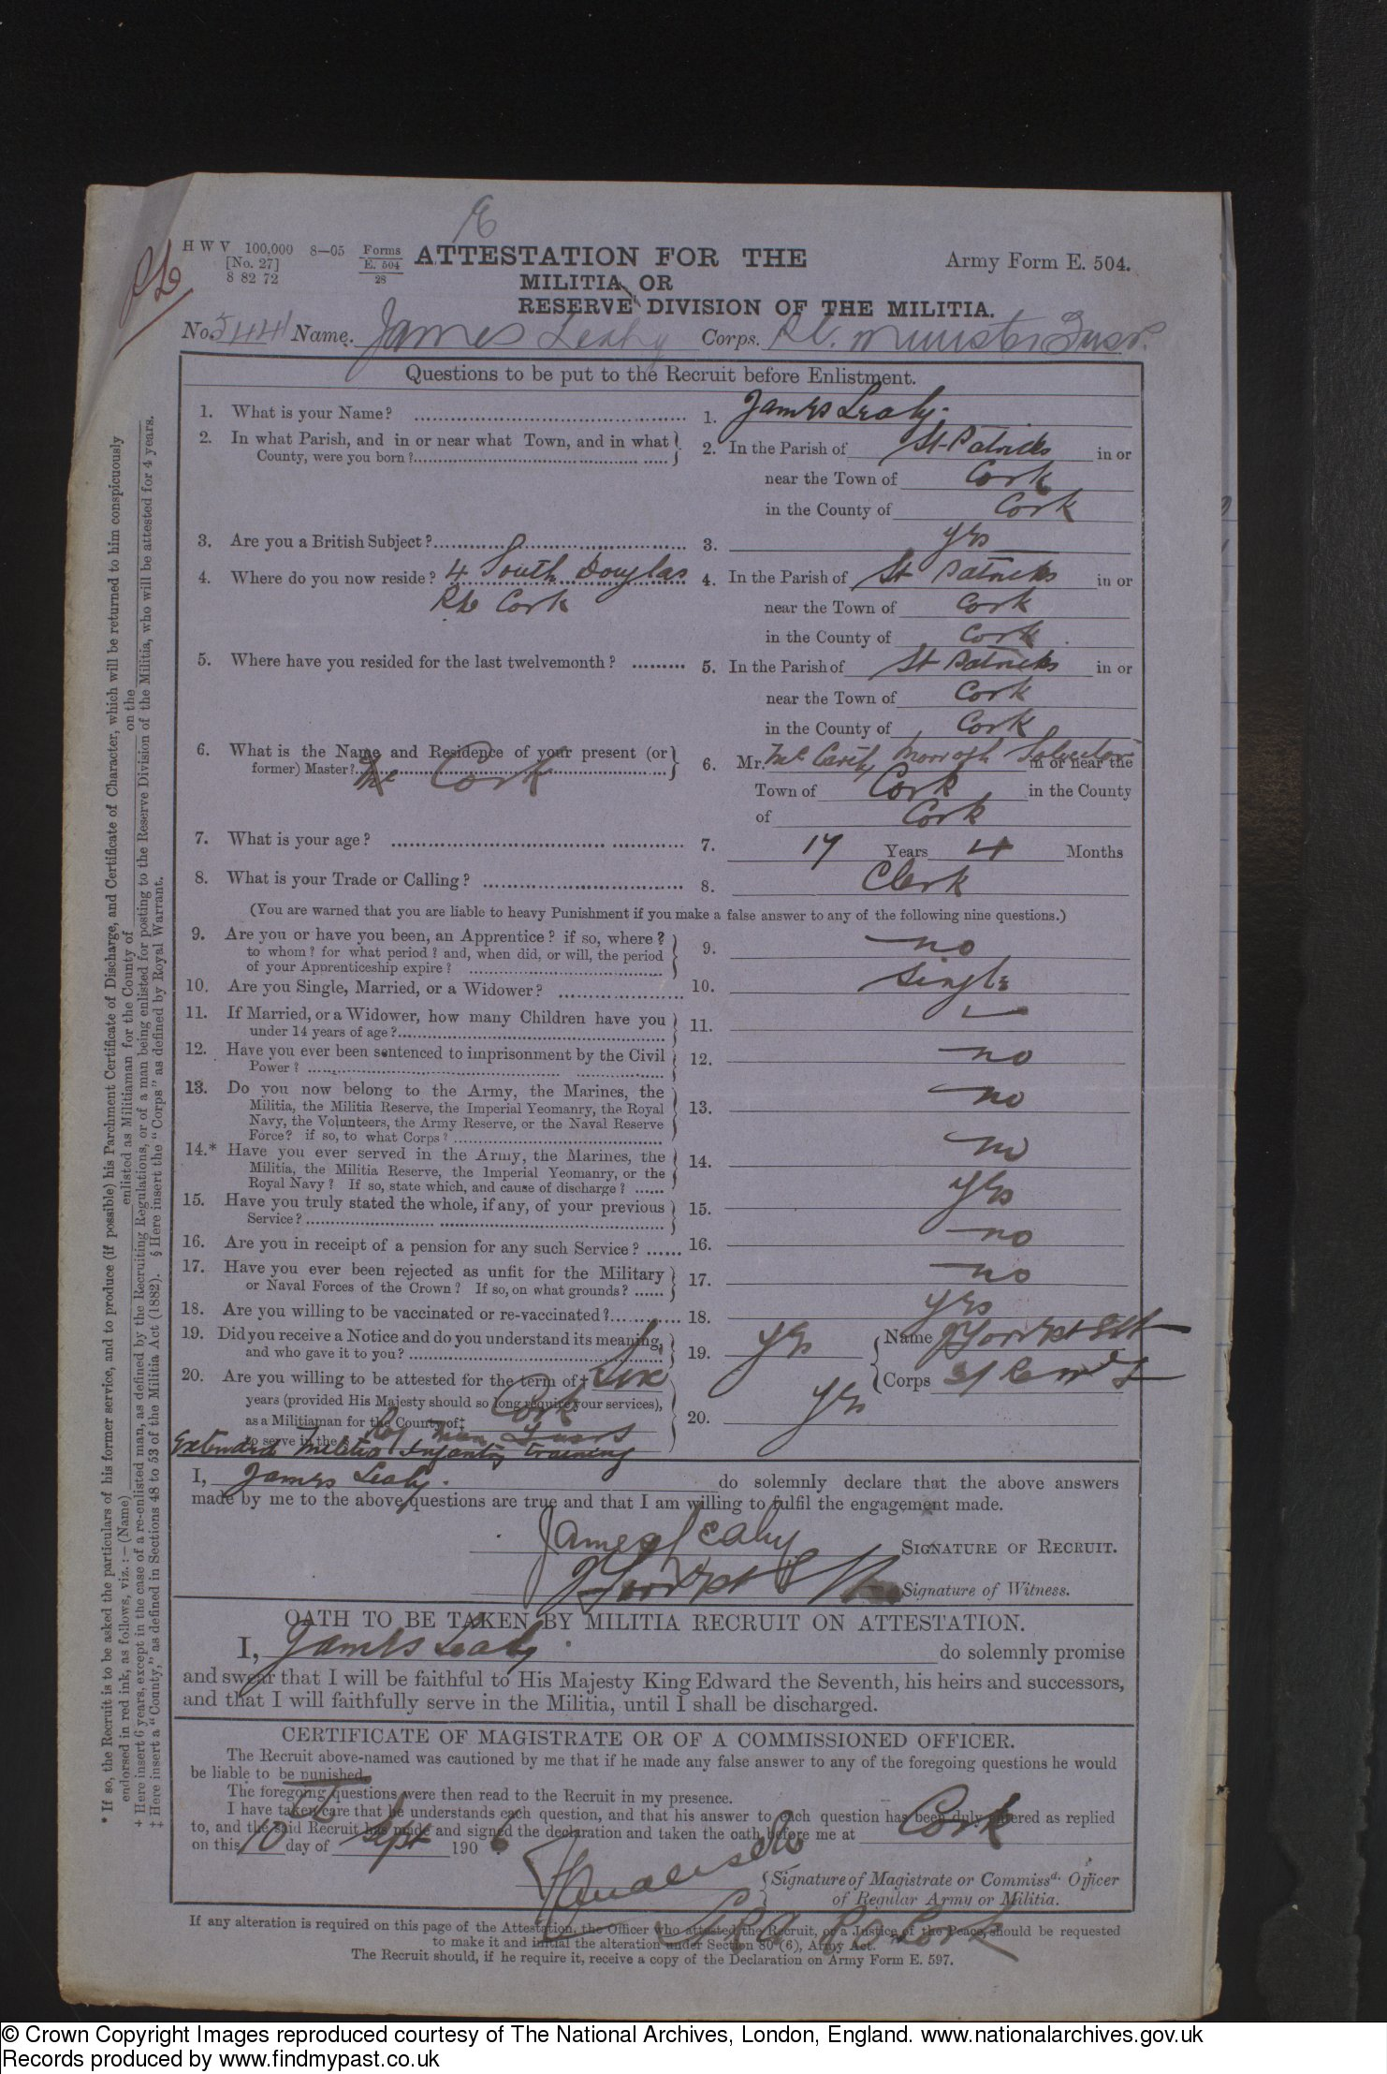
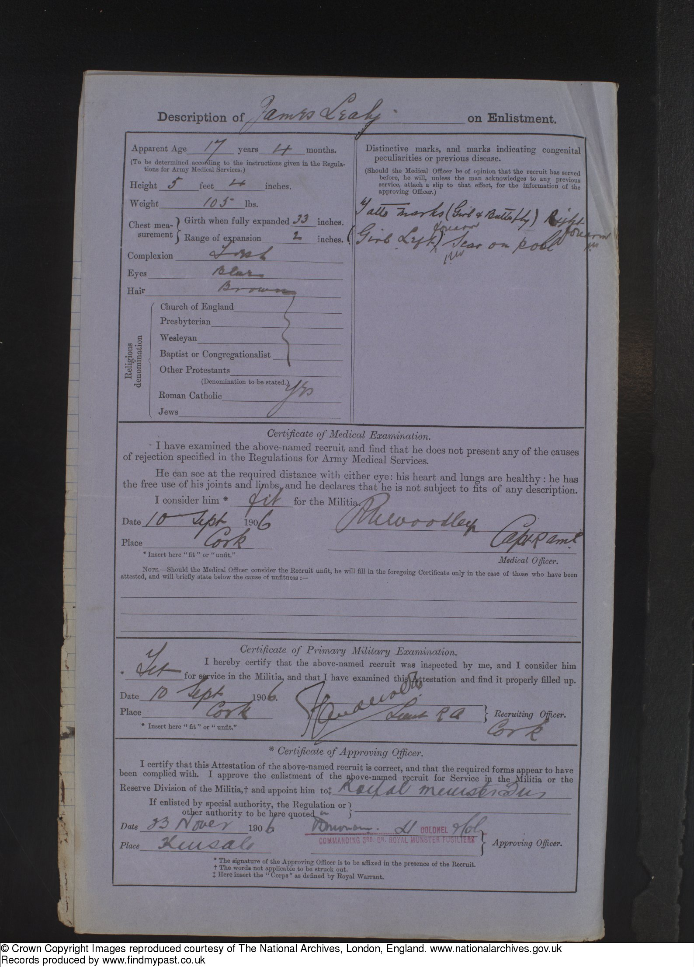

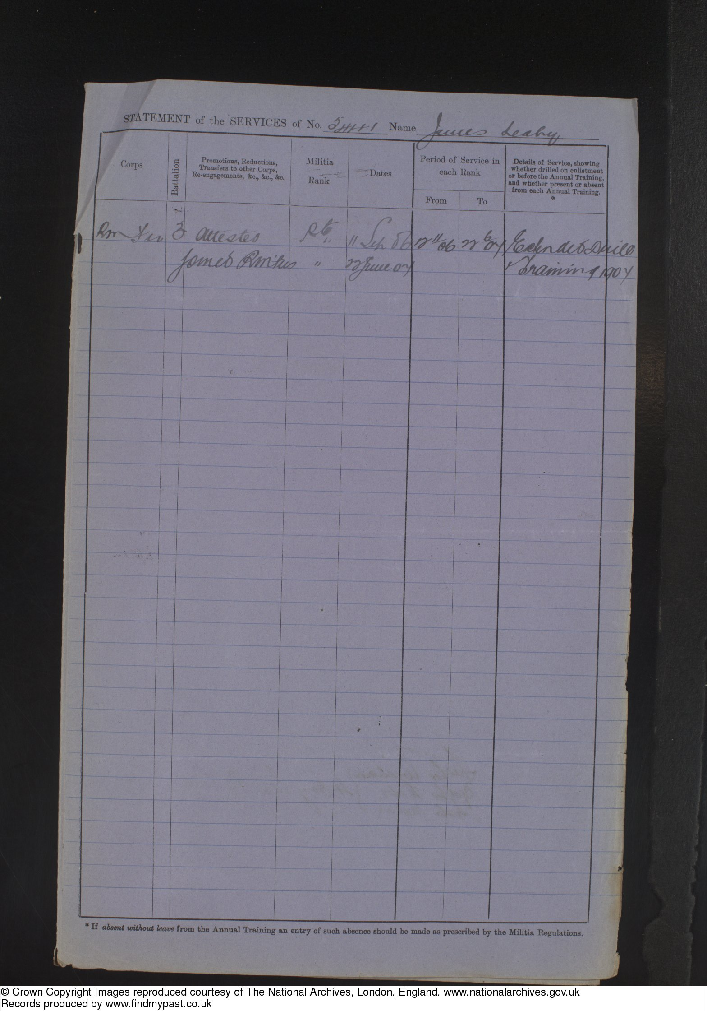

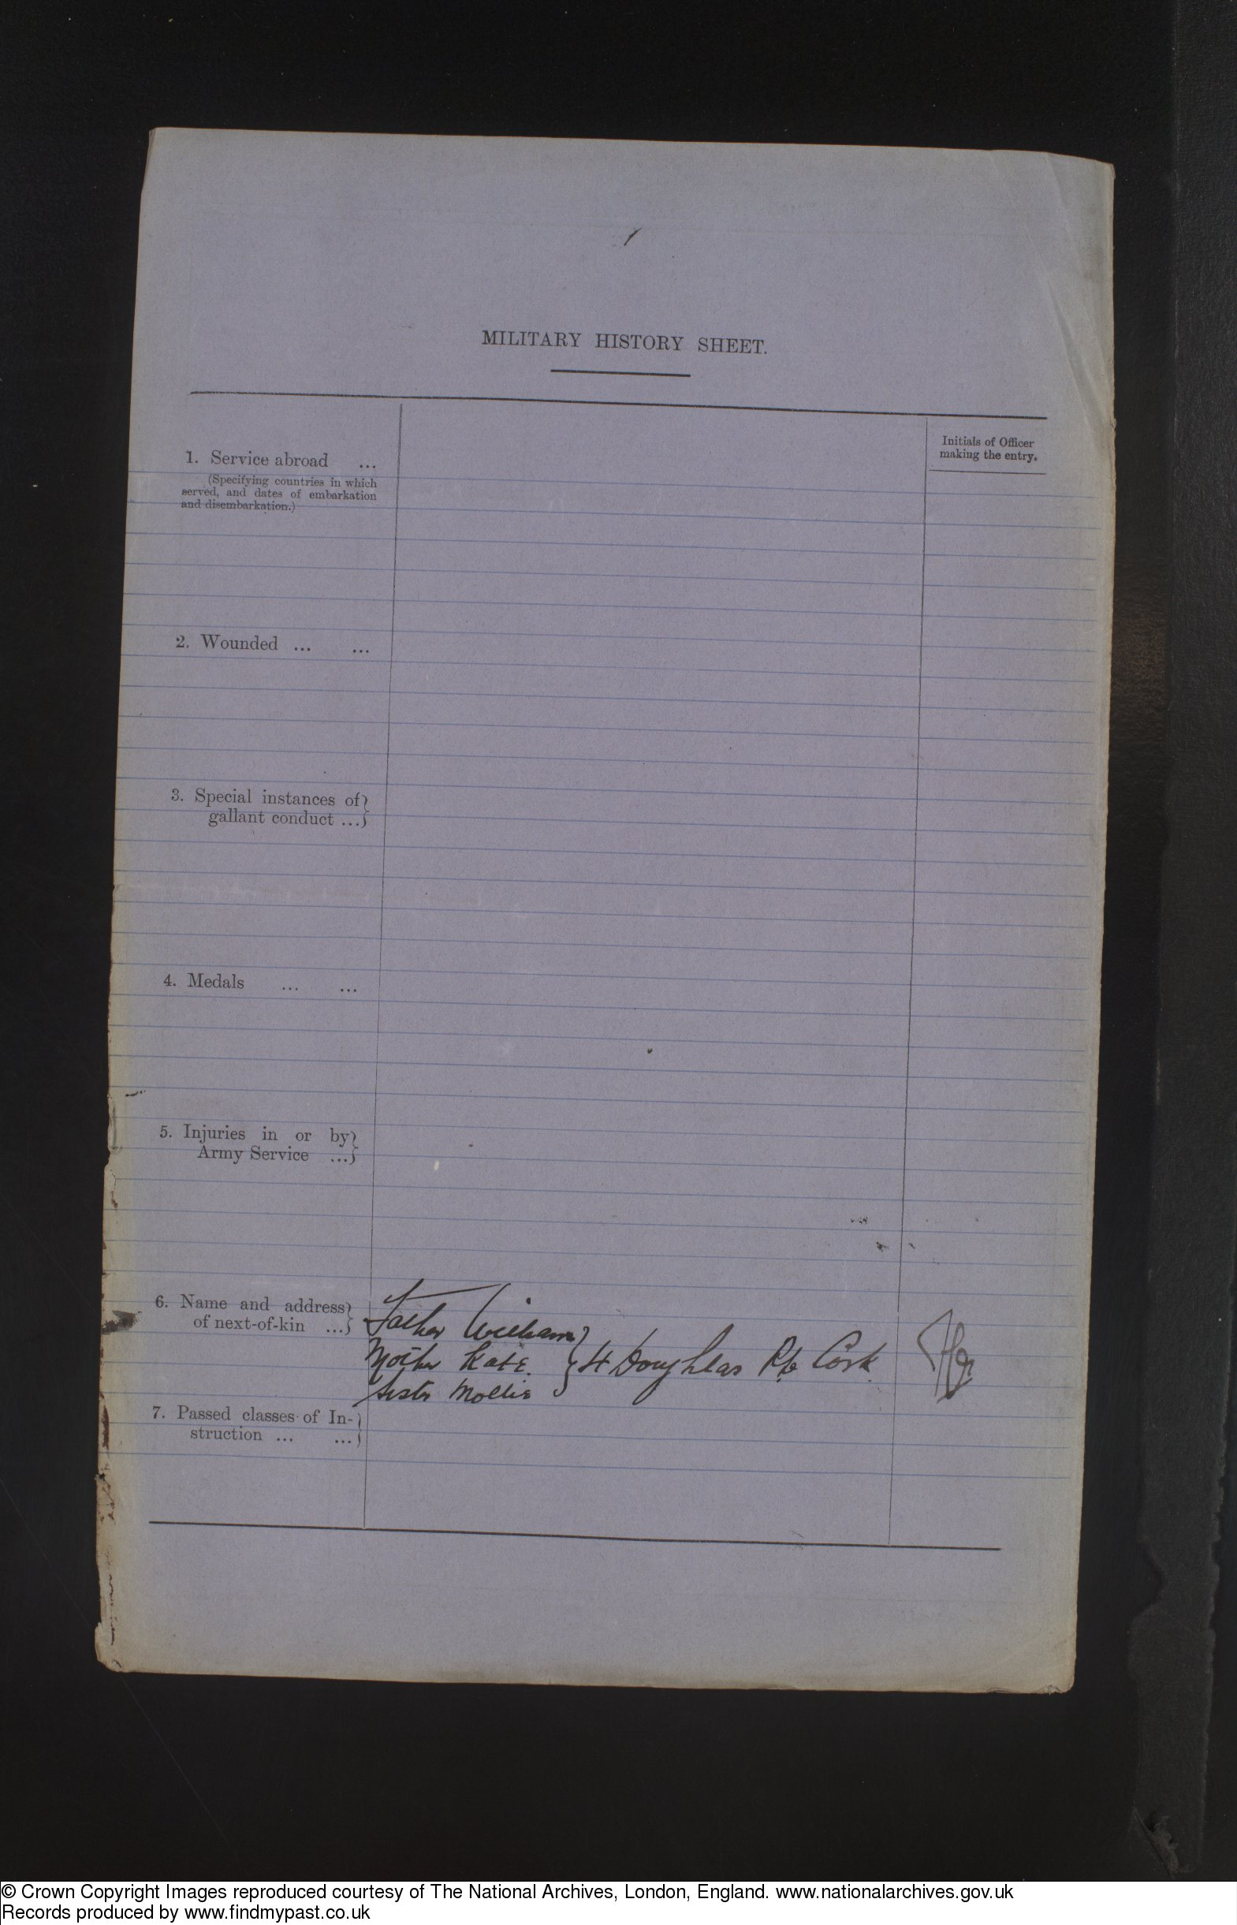

VARIOUS LETTERS SENT HOME BY JAMES AS PUBLISHED IN THE ‘CORK EXAMINER’.

(CE 2/11/1914 – Cork Examiner & date of publication) – CORKMAN AT THE FRONT – GRAPHIC DETAILS OF EARLY FIGHTING – The following letter has been received by the relatives of Sergeant James Leahy, a Corkman, at present at the front with the 2nd Batt Royal Munster Fusiliers:-

‘October 26th, 1914, 10 p.m. – Being on guard, I will avail of the opportunity to write you a long letter. In the ordinary course of events, this is a duty not sought after, but here it is an opportunity for a few hours’ rest, although no sleep. I am writing this stretched on a bit of straw in a sawmill, where we are at present billeted. My illuminant is a flickering candle; in the distance is the flash and roar of our heavy guns, each crash sending a souvenir to John German. Every time I see that muzzle belch fire I offer an earnest prayer that each shot has sent another crowd of the devils to their doom. No one knows the low, wicked deeds these inhuman monsters are capable of committing.

I’ll start at the beginning now. We reached a port in France on the 14th August, and saw ‘Fair France’ for the first time through a misty dawn. We had a day’s rest and off to the front, full of ardour, to meet the foe. Everywhere we went what a reception – flowers, fruit, and wines. The fellows were simply inundated with everything imaginable. At the
station a very rich French lady handed me a slip of paper. On it was ‘God bless England and her noble soldiers.’ On the back her name and address. I suppose she could not speak English, so got someone to write it to show her appreciation. I lost this during one of the eventful days which followed, and though it was a trivial scrap of paper, I prized it as a memento of the occasion.
At last we got to within sound of the artillery. I felt very creepy at first as I though of the fearful carnage I have seen so often depicted on the living picture screen; but, my God, how these pictures pale into insignificance in comparison with the reality of the life and death struggle in which we are now participating. We got into action, dug trenches, and waited. Hours passed, no sign. Two chaps near me went and got two fowl from a gentleman’s house (the family had left on the approach of the Germans). Their necks were wrung in the usual orthodox manner. We plucked them as well as Mollie could, lit a fire, and just had put them in an old tin can to boil, when bang! Shrapnel burst over our heads. We got the order to retire, so those hens are still boiling.

We carried on day after day under shell fire without ever seeing a German; in fact, I despaired of ever gazing on one of the beauties or having a shot, when suddenly the eventful day arrived which put the regiment’s name in the mouth of everyone.

Exactly two months to-morrow we were guarding a road about three miles long. I with about 20 more on the extreme right. We were drinking cider and eating apples which a woman gave us. All the time I had my eyes glued to the glasses, as I had a sort of feeling that they were in the vicinity, although there was not the slightest sign. One of our Hussars (a scout) passed and disappeared in an orchard about a quarter of a mile from me. In five minutes he returned, his horse flying faster than any racer, and shouted to me, ‘Look out Sergeant, there’s hundreds of them near you in the wood.’ My heart fluttered for a moment. I thought of you all, the quiet happy home, maybe Mollie preparing the breakfast. I thought of the songs and gaiety, of poor darling mother. I prayed that if I was to fall then you would be all brave to say, ‘Well, Jim is with Mud now.’ I said an Act of Contrition, and got ready to meet I knew not what.

I was just a soldier now again. All thoughts of home had vanished. I knew it was my duty to look after and keep my little section together, and right well they did their duty.

There was a minute’s silence, then the leaves on the hawthorn bushes over our heads began to drop. I knew it was more than the sighing autumn wind was the cause, as a rattle of musketry burst about 100 yards on our front. I told the fellows take a steady aim, waste not even one shot. We had been firing two minutes when a little chap named Linehan from Cork rolled into the ditch moaning his arm torn right off from the forearm. We tied it up as best we could to stop the flow of blood. The next chap, third from me, then got shot through the lungs. My God! How I prayed and fired. Then another chap from Fermoy, a little way up, got shot three times in one spot on the arm. Two Germans ran straight across an open gateway in front of me. I fired two shots, and one dropped. Of course he may have been hit by someone else; but, no matter what happens me, I’ll always pride myself for at least bringing him down. Of course we were firing at a crowd of others, but you could not tell anything definitely. Anyway, I gave this fellow his ‘coup de grace.’
Several more of our chaps fell wounded, including our young officer, who said to me, ‘My God, Leahy, isn’t this terrible – what shall we do? At the moment he got shot through the side his electric torch turned the bullet, bringing it out again and lodging in his belt where he found it. He is going to get it mounted. He then told me to keep firing as fast as we could, to pretend he had a lot., while he got the chaps at the other side away. When they were clear we made a dash for it through a thick hedge, with bullets flying. After going 300 yards I met the officer again, he was in great pain, and could only walk slowly. Myself and a man named O Brien stuck with him. I gapped all my bayonet cutting barbed wire, as he could not stoop.
We got to a village, where all that was left met, I was sent back as a escort to the ammunition mules. This delayed us as the rest could walk quicker than us. After half an hour myself and the two in charge of the ammunition came on two dead Germans (one an officer). The trooper was dead, with his dead horse lying on top of his leg. I never dreamt a person could be so mutilated, he was absolutely disemboweled. One of our officers (15th Hussars) told me to search his inside pocket for despatches. I couldn’t face it, he was in such a fearful state. I told a man named Wilson to do so. He had no scruples and pulled out a yellow form, and handed it to the officer. We then walked across to see the German officer, he was still alive, breathing faintly, with the top of his head blown off. Although almost unconscious he glared at us. I then went back to put one of Mollie’s letters over the dead trooper’s face, on which the sun was shining, when bang, and bullets came flying again from four mounted German Uhlans. A Sergeant of the Hussars shot one fellow, and the rest cleared off. That was the end of the tightest corner I ever wish to be in again. Billy Leahy and the rest were farther down the road than I, so I don’t know what happened to them. I’m even afraid to think it was so terrible. I sincerely hope and trust in God the poor fellow is a prisoner.

What sympathy I would have another time if I saw a person even slightly injured, yet I looked on these two Germans without a spark of compassion, because in this life and death struggle it is a life for a life. While a battle is raging everyone is bent on slaughter. Yet in a day or two after, out of 100 men, we could not get a volunteer to kill a sheep for dinner. That will just show you there is no such thing as bravery – the devil of slaughter is for a time uppermost. I should not say the devil in this case, but God, as this is a just and holy war on our side. Against this no one can gainsay.

To see the poor Nuns in dozens driven from their convent homes, toiling along the roads, no definite place to go to, all their worldly possessions in a little black bag, all bearing that same saintly resigned smile, and bidding us ‘Bon jour’ as we pass. They take refuge in houses deserted; they go anywhere to get away from those hellish Huns. The sight of those Nuns was the first thing that awake pity in my heart, and steeled me to fight with my comrades, come what may, to the bitter end.

It was frightful to see the refugees, thousands upon thousands, rich and poor, ill and crippled, toiling aimlessly along the road, anywhere as long as they got away from the shell-fire, leaving their cottages nestling on the verdant hillsides of France and Belgium to be destroyed by those inhuman monsters. The most pitiful sight I saw was a crippled father, with his son 13 years of age, pushing along the road in a wheelbarrow. Following was his wife with three barefooted children, all young. Mind you where we passed them was a lonely road, 10 miles from any village. I gave them my bully beef and biscuits, so did some of our chaps. Scenes like this were witnessed every day. I compared the roads to a river of life on which floated these poor human derelicts. Oh! If the people in England and Ireland could only realise the scenes of desolation which we are daily accustomed to witness, every healthy able-bodied man would offer his very life to crush this military maniac – a despot who wants to trample the whole universe under an iron heel that has crushed the life out of women and children. There is no end to the tales of their inhuman barbarism. I have heard a lot about their friendliness, but with my own eyes I saw a poor innocent agricultural labourer lying under a haystack in his field, abandoned to die, having been almost cut in two by a German sword. Only for our chaps accidentally seeing him he would have died within an hour. In another case I saw the Crucifixes in a gentleman’s house torn from the wall, and the image of Our Lord crushed under their feet.

I had my second Mass since arriving in France on Sunday week. You could hear the artillery while the organ was playing. Two extremes – Church bells and shell! What a difference from the quiet Sunday at home. And last Sunday we were digging trenches all day, with shells bursting 800 yards away. They burst first like a railway truck of coal dropped from a great height into the empty hold of a steamer. That is why we call them ‘Coalboxes,’ from the similarity and the dense black smoke that rises. They are also called ‘Iron Jelloids,’ from that popular advertisement.

If Willie could join the Motor Cycle Corps of the R.E. it would be all right for him. There is a little danger and excitement but nothing in comparison with the infantry. The chaps belonging to it are decent fellows and volunteer for the war. He could never stick the infantry, so I advise him to join the A.S.C. or R.E.
I meant to answer Alf’s letter, but did not get a chance, even to drop a line for the past few days, as we were entrenching, and when I return to billets, I’m either too tired for some duty, or late for post. May gave me a good laugh in her letter. Give her this to read, as it is meant for her too. Tell Moll when I return, I will never ask her for milk, as I have not used au lait for many a long day, and have become quite used to black tea – my one-time pet aversion. We get plenty of everything, so don’t worry. I am smoking a pipe now, and every night we get three spoons of run. I don’t like the taste, but it warms us up during the cold nights.
I wish this terrible war was at an end, and I safe at home once more. I thank God I am safe and well up to the present, but it’s a long way from Tipperary yet. What’s past is bad, but the final reckoning will be worse, but with God’s help I’ll return all right, and our brave army victorious. I received the paper to-day with names of the missing. I know several amongst them who I saw wounded, but God knows how many will answer the final roll-call when the curtain rings down on the most dramatic war that was ever staged in the history of the world.

How is poor Moll? I hope well. I would give anything for one line from her. At one French town we passed through I saw her image standing on the footpath watching the troops go by. It is an extraordinary thing, but a chap of the R.G.s gave me a letter to read to-day. It started ‘My dear Jim.’ Wasn’t that a remarkable coincidence?

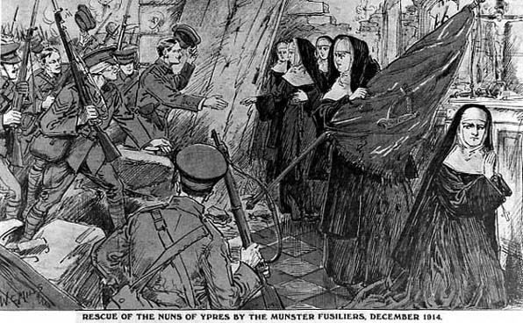

(CE 11/1/1915) – LETTERS FROM THE FRONT – MASS IN THE TRENCHES – MUNSTER FUSILIER AS ALTAR BOY – COMPANY SERGEANT-MAJOR J. T. LEAHY. A Company, 2nd Royal Munster Fusiliers, writing from the trenches on December 31st, to a friend in Passage West, Co. Cork, says:-

Dear Old Frank – I received your letter and beautiful card. I cannot thank you enough, and I will always wear them, and hope and trust in Almighty God to bring me safe. Frank, I cannot tell you how many miraculous escapes from death I’ve had since leaving the dear old sod five months ago, but thank God I am still well and safe.

Many of the chaps you know are killed, and God knows, Frank, I never thought I’d see the dawn of Xmas. Where death and wounds are ever companions, the feeling of sadness soon wears off, and things which would otherwise break your heart are just a passing occurrences.

Yes, I see my sister sent my letter to the papers, but that was my early adventures of the war. Since then I’ve been through such fearful times that those early experiences are … nothing. I suppose no one in the world has such an unique experience as myself had on Xmas Day in the trenches, and the priest came right up and gave a few who could be spared Mass, with bullets whizzing over us, especially at the Consecration. I served Mass and the priest since calls me his Altar boy. I had Communion with about 200 others in a hay barn during the Xmas week, and I am quite good now. Prayers more than anything else console me and every fellow is the same, so the war has been the cause of making us almost an army of saints.

Please remember me to all the family. Don’t send me anything. We get everything. All I want is your prayers, a Holy Communion from each of you, and a letter now and then. I hope the Symons are well. If I get home I will bring you a German souvenir. The shells are flying over while I am writing this. I will write you a long letter later one. – Your fond chum, Jim.

(15/4/1915)- FIGHTING AT THE FRONT – CORKMEN’S ACCOUNT – SERGEANT MAJOR JAMES LEAHY, (Royal Munster Fusiliers), of Douglas road, Cork, at present serving with the colours at the front, and who recently furnished an account of the Christmas truce, now contributing an interesting account of the battle of Neuve Chapelle.

At 7.40 a. m., 11th March, the artillery opened fire of a rapid character; simultaneously scores and scores of guns were banging away. They were being fired from all points of the rear. The noise of the guns as they spoke, the screaming of shells through the air, and the reports of the exploding shells was deafening. The heaviest thunder storm he had ever heard did not compare with it. Although the bullets from the German trenches passed over them, Tommy could not resist his curiosity, and risked looking over the trenches at the havoc being wrought by the bursting shells. He witnessed a heavy bombardment in December, but that one beat it by long chalks, After raking the German trenches, the guns were then concentrated on Neuve Chapelle itself. About this time the first line of German trenches were rushed, taken, and dispatch riders from the Brigade headquarters informed them that but few casualties occurred, and a couple of hundred prisoners were captured.

During an interval of the Artillery fire, a rather distressing incident happened. Their airmen were hovering aloft directing the artillery fire, and needless to say they were interested spectators. Suddenly, an aeroplane crumpled up and fell. It came to the ground with a crash. The occupants were beyond the need of aid.
Towards evening the reserve moved off to the lines of the captured German trenches. The Germans were shelling their lines as they advanced in single files across the fields. Nearing the trenches the Germans observed them, and rained shot and shell on them for all they were worth. Crossing these ploughed field with shell and shell pouring on you, at any pace but a sprint would be madness, so without waiting orders they raced for life to the cover afforded by the already captured first line of German trenches. Now only 100 yards from their firing line, and immediately in front was the enemy’s first line of trenches captured.
The German trenches were shattered beyond recognition, which fact speaks volumes for the effect of the artillery fire.
Preparations were then made for an assault on the German second line. With this intention the Yorkshires and two other regiments, followed by the Wilts, advanced over the intervening ground and occupied a ditch pro tem. About 4.30 p. m. the order came to advance to the attack, and this having been passed along, a simultaneous and general advance of the regiments mentioned, in more or less line formation, was made. It was during this advance they lost many by machine gun fire. However, they worked their way forward until they got to within 100 yards of the enemy. Then with bayonets fixed and a mighty cheer from the whole line they rushed the remaining distance. Whether it was that long line of khaki with service of glistening steel, or that mighty shout, the hearts of the Germans must have dropped into their boots, for they all came out of their trenches to a man and ran onwards them shouting in broken English, ‘mercy!’ They had left their rifles and equipment in the trenches.

Several hundred were left in charge of a platoon and laughed and patted austere but good-hearted Tommy on the back, and the latter made them get into formation of fours to march to the rear. That portion of the attack was practically a walk-over.

At dawn on the 11th the enemy counter-attacked in one part of the trench. After a sharp encounter they were driven off, but held a communication for some time longer from which they were finally routed with hand grenades.

The company of the regiment which bore the brunt of this attack lost many, but they put up a splendid fight, 100 prisoners were taken, and they insisted, before taking a step further, on shaking hands. Whilst the prisoners were coming in it was comparatively safe to walk about outside the trenches. In the captured trenches were found some large dug-outs with doors and windows of glass.

From behind a fort, the writer saw, through field glasses, brilliant charges by a Scottish regiment. Other regiments, indistinguishable even by aid of glasses. Whilst our regiment was charging a Jack Johnson dropped amongst them and they must have been a bit cut up.

That day (11th) and two following days the Germans shelled pretty heavily. However, all is well that ends well – they got back to billets for a well-earned rest on the 14th March.

The following letter has been received from Mr. J. Leahy (son of Mr. W. D. Leahy), of Douglas Road, who is at present serving with his regiment at the front. In his letter dated April 4th, he says:-

‘I can’t tell you the name of the place we were holding, but by a perusal of the papers a fortnight ago you will see where the biggest battle of the war was fought; that’s where I am. The village itself is obliterated, not a brick left. A most miraculous thing, though two large crucifixes are untouched; the crosses are riddled. It is a wonderful sight to see our Blessed Lord looking down on the dead with such a pitiful face, pity for the fearful sufferings endured before the final spark of life [flitted?] from maimed bodies.
Although we have buried hundreds of Germans, yet still lying in front of our trench are about 20, who will never be buried till the advance, as it is instant death for either side to stir, owing to the proximity of the fire trenches to each other. Holy Week passed very quietly, except on Easter Saturday morning, when both sides started blazing. It was hot while it lasted but considering the enormous expenditure of ammunition by the Germans the result to them was not satisfactory, only two of our chaps got wounded.

Father Gleeson arrived in the fire trench on Holy Thursday night, about 11 p.m. I was going down with a ration party, as that is the only time you dare stir. They opened fire with a machine gun on us, and we all dropped into a ‘Johnson hole.’ We were listening till the machine gun would stop to go on, when I discerned (through the thoughtfulness of a kind German who fired a flare light) Father Gleeson ploughing through the mud making his way up to his boys, as he calls us. I said: ‘Quick, Father, they have machine gun on this spot.’ He dropped into our ‘Hotel de Coalbox,’ and all he said was,’ How awfully interesting.’ We absolutely adore him, you know. When he arrived in the trench he walked the whole length of it, and at 2 a.m. got about thirty of A company together and recited the Rosary and sang ‘Hail Glorious St. Patrick’ and the ‘Ave Maria.’ Our fellows are really splendid. He can get over 500 in the battalion to sing any hymn out of the hymn books which were sent to us about three months ago. I erected an altar, and he said Mass on Easter Sunday. Father Gleeson sang the ‘Credo’ and the ‘Pater Nostri,’ and I had the privilege of serving Mass. We had no church bell to call us to prayer, so Father Gleeson got one of the look-out men to fire three rapid rounds at the commencement, at the consecration, and at the finish. Of course, this burst of fire brought a reply from the Germans, but as the bullets whizzed over the altar he took not the slightest notice.
There was heavy shell and rifle fire at dawn on Monday morning, and as Father Gleeson sat there under it all he turned to me and said, ‘How lucky I am to be here, as I shall be on the spot if anyone gets hit.’ He returned to the reserve trench last night, a typical soldier, covered from head to foot in mud and a sandbag tied around each leg to save his putties.

I have five spikes from German helmets and a new German rifle, which I should like you to have as a souvenir. We get a deserving rest tomorrow night after being in three weeks, with only an interval of forty-eight hours which we had back at the dug-outs. The trenches are excellent, roomy, and comfortable, and if only the clerk of the weather gazed on us with a favourable optic we would stay here for ever. I often sit in the trench and listen to the bullets going over, and if you have any ear for music you will find what a medley of sounds they individually make. There is one which strikes a stone somewhere and passes over with a singing sound; then another with a wicked waspish sound, as much as to say a good job I didn’t get at you; then another with a low whining sound as if lost and looking for a billet to rest in; then there is the sharp deliberate crack of the sniper’s bullet, which seems to have a definite object in view, generally an unfortunate ration carrier or a stretcher bearer taking back a wounded man to the first aid dressing station; and then there is one which you never hear – that’s the one that send you either home to Cork or to eternity.
The sun is shining, a lark is soaring over the trench singing blithely. The Germans are quiet; our 18-pounders are spitting in the rear. We go out for a rest, wash, and brush-up tomorrow, so everyone is gay but roll on home.

(CE 2/7/1915) – MUNSTERS AT THE FRONT – BATTLE OF 9TH MAY – THRILLING DESCRIPTION – CORK LAD’S BRAVERY – Mr. Leahy, Monkstown, has received the following from his brother [probably C.S.M. James T. Leahy], with the Royal Munster Fusiliers:-

‘I know it is about time I wrote you a letter, but I can tell you we have had a fearful time. No doubt you saw in the papers the glorious name again earned by the regiment. Well, if ever heroes were born the fellows were. I have been in some dirty work since the start, but, my God, the 9th of May will ever live in my memory. It was the spirit of everyone that was so astonishing. Several days before we knew that at 5.37 a.m., on 9th May – it was death or glory – that the German trenches which were impregnable since October were to be assaulted, yet there was never such a happy laughing crowd.

The day previous to the charge close on 800 men received Holy Communion, wrote their names and home address on their hymn books. I have seen sights, but the faith, piety, and sincerity of that congregation, each man knowing that death was staring him in the face, would make anyone in this world proud to be a Catholic.
The night before the charge we lay on the road a short way from the trenches, Father Gleeson went down the ranks, saying words of comfort, bidding goodbye to the officers, telling the men to keep up the honour of the regiment. At dawn then on that lonely dark roadside, lit up now and then by intermittent flashes from our own or German flares, rose to heaven the voices of 800 men singing that glorious hymn ‘Hail Queen of Heaven.’ There were no ribald jest, or courage buoyed up with alcohol, none of the fanciful pictures which imagination conjures up of soldiers going to a desperate charge; no, there were brave hearts without fear, only hope that God would bring them through, and if the end – well, only a little shortened of the allotted time span. Every man had his Rosary out reciting the prayers in response to Father Gleeson, just as if at the Confraternity at home, instead of having to face death in a thousand hideous forms the following morning.
Then dawn broke, a beautiful morning, the sun shining brightly, just a day that makes you feel that life is worth living – the beauty of nature did not worry the boys, they were more intent on oiling the mechanism of their rifles and looking to their bayonets, and I can vouch for it that a more happy or jocose crowd never lived. Every fellow was laughing and joking even when the most terrific bombardment in the history of the war was raging, shells of all sizes both ours and Germans, shrieking overhead in one continuous moan.
Five minutes before the bombardment the order was given by the officers: ‘Are you ready, lads? ‘Yes,’ came the cry. Then over and over the parapet like one man leaped 800 forms, the four green company flags leading. The first trench was taken in no time, then on to the second. But what a hail of lead met those gallant men. The ground was dotted with brave Irish soldiers, yet on they went. The green flag was raised on the parapet of the main German trench, and in they went. The numbers to reach the objective were too few to hold the position, and eventually, and with reluctance, they had to retire. The words of the Commander of the 1st Army was enough to show what a splendid achievement had been accomplished. – ‘Men,’ he said, ‘I am proud to command such a gallant regiment. You were the only battalion to penetrate and storm the German trenches although under a hellish fire. You have added another laurel to your noble deeds during the present campaign. You will now return to rest, and another day when wanted I know you will do anything within human power to uphold the traditions of your regiment and the army.’

I could not individualise the bravery, every man was willing and happy when the hour came, officers and men were heroes, but I feel I must tell you about one man – I can’t very well call him a man, as he was more a boy, but with the heart of a lion beating within his Irish heart. The man I refer to is Private Barry, whose poor mother resides in Douglas Street, [Cork]. He was absolutely fearless, never happy unless running the most dangerous risks. He appeared in orders for the D.C.M., after being killed, for bravery during operations in December. Now his name has gone forward for the V.C. If he is granted same it will be a most unique honour. In fact I don’t know of another instance of the grant of the two. Captain Hawkes was lying in the open badly wounded; Barry was also wounded. He struggled over, got Captain Hawkes, and started back with him again; he was wounded, but still struggled on, gaining the parapet. With all his remaining strength he pushed the officer over into safety as a third bullet got him and extinguished the life of one of the most daring and bravest men in this or any other regiment. He lies in a little grave close to the Commanding Officer, and the sincere wish of all is that the V.C. will be granted to the poor old mother, and that she may get some pecuniary gain to help her in her declining years for rearing one who is the pride and talk of the regiment.

We are all at rest now, having a fine time, swimming, sports and concerts almost every day. Why the only reminder of war is the distant rumble of artillery.

I will have to draw to a conclusion as madam may be angry if I burn the midnight oil. Father Gleeson is going on leave, and appears more like Santa Claus than anything else with all the German souvenirs he is taking home, but I think his most precious souvenir is the love and esteem he is taking back to dear old Ireland – the love which everyone in the battalion has for their own ‘Soggarth Aroon.’

(CE 27/7/1915) – MUNSTER’S DEATH – Mrs. Cole, of 22 Abbey Street, Cork, has received the following:-

‘Dear Mrs. Cole,
I am writing this letter to tell you of the death of your dear son (No. 3888), Sergt. Cole), who was killed in action on 16th, about 9 a.m. We are in the trenches still, and will go out tomorrow (if I live with God’s help), as the trenches we are in at present are a living Hell. May Almighty God strengthen you in your sad affliction. You have the consolation of knowing that your son received Holy Communion on Sunday. I buried him with five others which the same shell killed. I left his Rosary bead and hymn book in his pocket, and erected a little wooden cross over his grave. His death was without the slightest suffering, death being instantaneous. When I found him he was just as if asleep with his face resting on a little pet dog he had with him. I buried the little dog a bit away at the foot of the grave, as it was a great favourite and died with him. You will probably be informed of his death from the War Office later on, and the money he is in credit will be paid you from the Regimental Paymaster, Cork. There were six of them killed together, and I would give anything to known the address of a man named Bulman, who is a fisherman (married), living on the Coal Quay. Perhaps you’d enquire, dear Mrs. Cole, and let his poor wife know, and tell her to write to me. God grant that you will bear your trial. Please offer up a Holy Communion for me when doing so for your dear son for my safe return to Cork.

Yours very sincerely,
8580,
Coy. Sergt.-Major James T. Leahy,
A Company,
2nd Royal Munster Fusiliers,
B.E. Force.

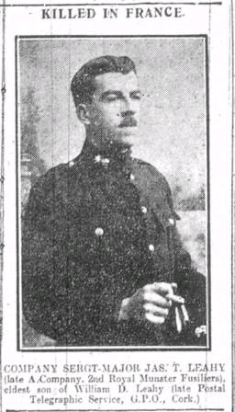

(CE 9/10/1915) – KILLED IN FRANCE – COMPANY SERGT.-MAJOR JAS. T. LEAHY, late A Company, 2nd Royal Munster Fusiliers, eldest son of William D. Leahy, late Postal Telegraphic Service, G.P.O., Cork.

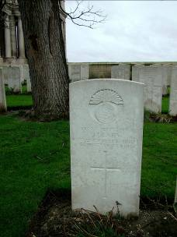

LEAHY, J., COMPANY SERGEANT-MAJOR ( 8580). 25th September 1915.

Dud Corner CWGC, Loos, France.

(CE 11/10/1915) – LATE SERGT.-MAJOR J. LEAHY, 2nd MUNSTERS – AN APPRECIATION SKETCH.

Through the death of Company Sergt.-Major James Leahy, of the 2nd Munster Fusiliers, his regiment has lost a splendid soldier, one whose gallantry gave a lead even to its brave men, whose sense of duty was not surpassed by the highest in command, and whose character was irreproachable. Co.-Sergt.-Major Leahy was well known in Cork, particularly in the South Parish. When a boy he spent two years in the office of Mr. M. J. McMullen, who was at one time City Engineer, and he later entered a solicitor’s office. Being of an adventurous disposition, the life of a soldier appealed to him, and he joined the 2nd Munsters. Having completed seven years’ service, he re-engaged for a further term two months before the declaration of war. He left for France on August 12, 1914, was at Mons, and all the later principal engagements. Several of his letters home to his people, and those written to his friend ‘Frank,’ were with pleasure published by us, as they were some of the very best articles that have been written in connection with the war, and that is even taking into consideration the work of the brilliant literary men who are acting as correspondents for agencies or journals.

Co.-Sergt.-Major Leahy’s letters were graced by an ease of style, he possessed powers of intelligent observation, his ideas were grouped and ranged into perfect sequence, and his story, told in a choice of language that was clear, lucid and exceedingly graphic, yet charmingly simple.

The first letter we published attracted considerable attention to the writer, for it may be termed a powerful story of the war. It was dated October 26th, and he mentions that being on guard he was availing of the opportunity to send home a long letter. His light was a flickering candle, in the distance was the flash and roar of the English heavy guns, ‘each crash sending a souvenir to John German.’ He wrote – ‘I offer up an earnest prayer that each shot has sent another crowd of devils to their doom. No one knows the low, wicked deeds that these inhuman monsters are capable of committing.’ He starts his story from the 14th of August, and his description of the approach of the vessel to France, the reception and other incidents would be proudly owned to be any literary man. His feelings as he hears the first booming of the artillery and his march, carrying him all the time nearer to the scene, are so well conveyed to the reader that they grip with no small force. The climax of the first dose of shrapnel breaking in their midst he converts into a humorous situation. Sergeant Leahy only seeing the comic side of it, for it forced him and his companions to leave an almost cooked dinner on the fire of two fowls that had been procured with a good deal of chasing.

On the 27th of August he came face to face with his first Germans. He tells in his letter how he and his men were drinking cider and eating apples that a woman had given them. The enemy was in the neighbourhood, but not immediately expected, but he had ‘a feeling that they were in the vicinity.’ He then tells how a Hussar scout discovered the enemy in an orchard, how he galloped back, shouting: ‘Look out, Sergeant, there’s hundreds of them near you in the wood.’ ‘Then,’ says Sergeant-Major Leahy, ‘my heart fluttered for a moment.’ Home thoughts came into his mind; he thought of home, songs and gaiety, and he prayed if he fell ‘they would meet the news bravely.’ ‘I said an Act of Contrition, and got ready to meet – I knew not what. I was just a soldier now again. All thoughts of home had vanished. I knew it was my duty to look after and keep my little section together, and right well they did their duty. There was a minute’s silence, then the leaves on the hawthorn bushes over our heads commenced to drop. I knew it was more than the sighing of autumn wind was the cause, as a rattle of musketry burst out about 100 yards on our front…We had been firing about a minute when a little chap named Linehan, from Cork, rolled into the ditch moaning, his right arm town off from the forearm.’

Then he details a grim story of the fight. He throws a powerful light on the two-fold character of the soldier. ‘What sympathy I would have another time if I saw a person only slightly injured. Yet I looked on the dead Germans without a spark of compassion, because in this life and death it is a life for a life. While a battle is raging, everyone is bent on slaughter. Yet in a day or two later we could not get a volunteer to kill a sheep for dinner. That will show you that there is no such thing as bravery – the devil of slaughter is for s time uppermost. I should not say the Devil in this case, but God, for this is a just and holy war on our side.’ He then paints a powerful scene of the flight of the nuns and other religious from before the hellish terrors of the Prussians, and he completes his weird tale by: ‘The sight of those nuns was the first thing that awakened pity in my heart and steeled me to fight with my comrades, come what may, to the bitter end.’ Then he tells of the awful sights on the roads and in the fields of the lay refugees of murdered agricultural labourers. ‘I compare,’ said he, ‘these roads to a river of life on which floated those poor human derelicts. Oh! if the people of England or Ireland could only realise the scenes of desolation which we are daily accustomed to witness, every healthy, able-bodied man would offer his very life to crush this military maniac – a despot who wants to trample the whole universe under an iron heel – a heel that has crushed the life out of women and children. There is no end to the tales of their inhuman barbarism.’

In this letter and in others he vividly depicts the inhumanities that the conquering hordes visited on the people, or the sacrileges and the terrible desecrations. This deals with but one of his many letters, and owing to want of space several excellent parts of it are untouched.

In a letter published February 20th* he tells graphically how he felt under shell fire. ‘As a shell comes whistling towards you, your stomach seems to cringe up. You duck (as if that would be any good), you look around to see everyone doing the same. Then all laugh for being so foolish, but still it is what happens each time ….. Do you remember how I would shrink from looking at a dead person nicely laid out on a bed? What about trying to sleep with dead chaps all over the trench, above, behind and next to you? But a dead soldier is different. He is like yourself – a bundle of muddy khaki, unless it is a shell – and then I draw a veil.’

Company Sergeant Major Leahy was a most exemplary Catholic; he served Mass as often as was possible, never missing an opportunity of attending at the Divine Sacrifice and receiving Holy Communion. His profound sense of religion and his splendid character endeared him to the chaplain of the regiment, who used lovingly call him ‘my altar boy.’ Amongst a regiment of the bravest of the brave, for such is the character of the Munsters, he held a high place amongst a regiment of God-fearing, deeply religious men. He was looked on as a man of saintly life. First and last he was a true man, and Cork may well honour the memory of Company Sergeant Major James Leahy, of the 2nd Munsters.

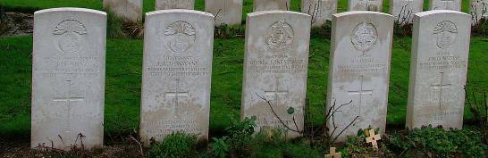

Dud Corner CWGC Cemetery, Loos, France. Left to right:- C.S.M. Leahy, Lt. Ronayne, Capt. Ward (Royal Sussex Regt.), Capt. Orme (Royal Sussex Regt.), Major Considine.
Grave Reference: VII. E. 11.

A DESCRIPTION OF THE DEATH OF JIM LEAHY.

(CE 25/10/1915) – EXCERPT FROM A SERMON GIVEN BY REV. FR. LEONARD, OSFC, AT THE MISSION FOR THE MILITARY, ST. PATRICK’S, LOWER GLANMIRE ROAD, CORK.

‘…Amongst the ‘Munsters’ will ever remain as a household word the name of Father Gleeson. That man’s life in the firing line does not look the life of a coward. Amidst the fury of the battle now and again he snatches a little time to write words of comfort and consolation to the father or mother or sisters of some poor Tommy he attended while dying in the trenches. The goodness of the man’s heart that could find time for such an exercise of charity – and mark you, his letters are not to the rich and wealthy, but to the poor. I have here one dated 1st October, in which he tells the poor father how Sergeant-Major Jim Leahy died:-

‘I was attracted towards the spot, the really dangerous part of the firing line. At last I met four Munsters carrying a stretcher. Hastily laying it down, they ran towards me saying, ‘Father, hurry up, the poor fellow is dying, poor Sergeant-Major Leahy.’ I administered the Sacrament of Penance and Extreme Unction, and said the prayers for the dying. The bullets began to come pretty close and thick. I ordered the men return to the shelter of the trenches. Lying flat on the grass beside the stretcher, I watched the last struggling gasps of your saintly son. He was a typical Irishman and a model Catholic. He got wounded going out to bring in the body of Major Considine.’

I know not which to admire more, the heroism of Jim Leahy or the priest in that bullet-swept field lying beside the poor dying Catholic soldier. …..’

SOME OF JAMES LEAHY’S FAMILY.

LEAHY, CORPORAL W. D., DESPATCH CORPS, ROYAL ENGINEERS – (CE 4/3/1916) – MOTOR CYCLE CORPS –

CORPORAL W. D. LEAHY, a Cork motor cyclist, who joined the Despatch Corps of the Royal Engineers on the outbreak of the war, with many more Cork lads. He is a brother of the late Sergeant Major Leahy, Royal Munsters, who was killed last September in France.

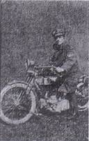

MURPHY, MICHAEL, SERGEANT, ROYAL IRISH RIFLES – (CE 23/3/1916) – 9961 Sergeant Michael Murphy, C Company, 1st Battalion, Royal Irish Rifles (formerly of the G.P.O., Cork), and of 9 Marina terrace, Cork). He was a popular athlete of the battalion, and on the outbreak of the war returned to England and proceeded to the front. On the 17th of March, 1915, he was seriously wounded at Neuve Chapelle. His younger brother, William (a Sullivan’s Quay School pupil), is serving in the Royal Field Artillery at the front since last August. He is also a first cousin of the late Company Sergeant-Major Leahy, Royal Munster Fusiliers, killed at Loos in action. Sergeant Murphy is now stationed for the present at Portobello Barracks, Dublin.

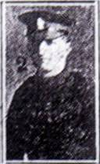

MURPHY, WILLIAM F., BOMBARDIER, ROYAL FIELD ARTILLERY – (CE 25/5/1917) – CORKMAN HONOURED – BOMBARDIER WILLIAM F.(late of 9 Marina Terrace, Cork), Royal Field Artillery, who was awarded the Military Medal and bar. He was a pupil of Sullivan’s Quay School. He is only 20 years of age, and joined up when the war broke out. He has been through Loos, Hulluch, the Somme and Arras battles.

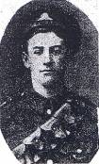

OUR GRANDPARENTS.

(CE 7/4/1917) – JAY-LEAHY.
March 31st, at Douglas R.C. Church, by the Rev. Father W. McCullagh, P.P., S.Q.M.S., Walter F. Jay, Army Service Corps, son of Mr. W. E. Jay, late of Great Yarmouth, to Madeline Eileen, third daughter of Mr. W. D. Leahy, Telegraph and Postal Service, G.P.O. Cork.

(CE 30/4/1917) – A MILITARY MARRIAGE – STAFF QMS WALTER F. JAY, ARMY SERVICE CORPS, who was married on March 31st, 1917, to Madeline Eileen Leahy, third daughter of W. D. Leahy, late Postal Telegraph Staff, Cork, and sister of the late Sergeant-Major James T. Leahy, 2nd Battalion, Royal Munster Fusiliers. In a despatch dated 30th April, 1916, forwarded to the Secretary of State for War by General Sir D. Haig, G.C.B., the name of SQMS Jay was mentioned for gallant and distinguished conduct in the field. (Photo, Wilkie and Son, Cork).

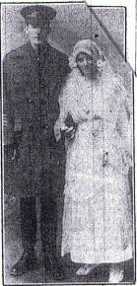

(CE 5/10/1915) – BRAVE MUNSTER OFFICER – MAJOR J. W. CONSIDINE.

The death in action in France is announced of Major J. W. Considine, 2nd Battalion Royal Munster Fusilier. Major Considine had 13 ½ years’ service. Having passed through Sandhurst, he was gazetted to the Munster Fusiliers in April 1902. He served in that distinguished regiment in Gibraltar and in India, when he took part in the North-West Frontier Expedition, 1908, for which he received the King’s Medal and clasp, and lately he served with the 1st Battalion in Burma. He has been in France since April, and commanded the 2nd Battalion for 4 ½ months. He was a keen sportsman, and was well known in Scottish and Irish golfing circles. Father Gleeson, the chaplain of the battalion, in a letter to Mrs. Considine, who lives at 29 Royal Terrace West, Kingstown, says:-

‘Having displayed the utmost gallantry, coolness, and initiative, your devoted husband, leading his company under heavy rifle and machine-gun fire, was struck by a bullet. It penetrated near his mouth, and passed right through his head. His glorious death was a sudden, easy, and soldierly one. Devoted and loyal Catholic that he was, he assisted with great fervour at the Holy Mass which I celebrated for the battalion on the morning before the battle, and all received Holy Communion. He heard his last Mass in the middle of a dense wood even while the rain continued to pour on us, as it had done for hours the evening before. I am burying the body in ____ Cemetery this morning, side by side latter Sergt. Leahy (A Company). The latter made heroic efforts to rescue your husband’s body, and it is said, lost his life in doing so.’

Major Considine was married to a daughter of ex-County Inspector Law, who is well known in Tralee.

(CE 18/3/1916) – MUNSTERS IN THE ‘BIG PUSH.’ (Battle of Loos)

I will now take you into the final phase of the ‘big push.’ I will now attempt to show you the splendid individual initiative that forms the main characteristic of the Munsters – in a word, as I said before, I will show you the Munsters at their best –

They smashed and tore,
And literally swore,
On the road that led to glory.

These lines, rough and ready as they are, devoid of polish and timbre, sum up in a very complete manner the conduct and work of our boys ‘out there.’ This spirit should be more realised at home. I for one shall feel content if only I can imbue a little of that spirit into my countrymen, who for some unknown reason have hesitated to come and offer their support in this great fight, wherein the honour and ultimate freedom of our country rest. I pass on, I have no time for delving into that realm at the moment. My subject is the Munsters and their glorious heritage which is vividly manifested in their daring fighting qualities.

We are now behind our own first line, and the time has come when we are to throw our weight where it will be most needed, and then sweep on to our objective. The boys are cheering and laughing. A vociferous yell rent the air when I drew their attention to the Field Artillery, which had now pulled out to bombard the flanks of the enemy defences which were still holding out. I have said in a previous article that this was living; I now go further and say it was life ephemera, how ever disgusting and abhorrent the immediate environment may be. In such circumstances one has not time to reflect. It is well. It would spell disaster.

Events moved rapidly from now on. We moved rapidly from now on. We jumped our own first line, and waded our way beyond the barbed wire, and so into the real heart of the fight. I have told you that Hulluch was our aim, and that it lay near our left front. There was a fight nearer home, and the boys would not consider themselves well handled were they denied the opportunity of coming to blows once they knew they were really in on the ‘great game.’ Reliable data is not immediately to hand – I refer to my Press cuttings and the despatch bearing on the fight. A very dry article indeed. The situation was it appeared – I speak from memory – at this moment was that the 2nd Brigade were held up by a strongly fortified redoubt a little to our right front, and offering very serious resistance. If my memory is correct, and I have no reason to doubt it, we should not have attacked this place, but sweep on to our destination. ‘Green’s Force’ were to dispose of this. This force would probably number about 1,000 or 1,500 men, The Munster numbered about 500 all ranks, and were eminently successful in disposing of this opposition, and so cleared the road for the advance of the 2nd Brigade. This is no hallucination or thought wandering. If it is then life is but a dream, and this terrible drama in which the men of Munster play a noble and soul-stirring part, is but a horrible nightmare from which we shall presently awake. Official minds never dreamt on the possibility of that work being accomplished by a third or perhaps one half of their estimated requirements. The brain bugs knew they had the Munsters, but probably failed to appreciate the splendid and magnificent material of which they are composed. In the face of a fact of this nature can you wonder at me when I repeat, as I have often done, that we have every reason to be proud of our splendid provincial battalion. Can you wonder at me voicing to the world at large, if such were possible – and it is, the splendid fighting qualities that are the inherent abilities of all Irishmen. This I shall continue to do. I know full well that I am lacking in qualities of expression. Would that I were afflicted with the disease known as parrhesia. I leave the task of handing the glorious achievements of the Munsters down to posterity, to far able pens than mine. I shall be content to do what little I can, conscious of my failing in this respect.

Only one gun was firing now. This was one of the naval 4.7s from the village of Philosophe. It was engaged in helping out the right flank of the Brigade, which was being held up by (evidently) an immense number of enemy machine guns. It was assisted by the Munsters on the left of that position, who went at it nobly and heroically. Up and away again by small parties under the direction of Major Considine, who got killed at this point. He died a painless death. Would that I could say the same of that other noble soul who went to recover his body – C.S.M. ‘Jimmy’ Leahy. This man was wounded by an explosive bullet. None other could have inflicted that wound. I passed the prostrate form of the officer, and got slightly delayed by some entanglements, and here I got wounded. Let me mention here in parenthesis that I had no idea how hard a bullet could strike. I was out of it.
The curtain had rung on the climax so far as I was concerned. Thirty or forty yards away I could hear the roar and the cheer of the boys as they threw themselves on to the Germans. In my heart I felt an inward throb of pride at the wonderful behaviour of my comrades. They were grand. I felt happy that I was a member of one of the grandest regiments in the whole British service – just a solitary one. They were splendid. If our people at home only saw them that morning on the blood-soaked plains of the Artois region as I saw them. If they could only be made to view them, even in the perspective, what feelings of pride and animation would course through their veins. They would know then as I know that the cause for which they are fighting is a true and just one. These were not picked nor highly trained troops. They were not men who had been specially trained for the special purpose of delivering such assaults. These were men who, but a few short months before were to be found in comparative safety, peace and comfort in any of the towns or townships in dear old Munster, and here they were trying their skill and daring with the most highly and scientifically organised troops in the world. Troops whose moral ability and power were the result of years of assiduous thought and study. The contrast you would hardly conclude is fair. But there is the fact – the hard, irrefragable fact. I have also said that they knew that they were good enough of them. Here was fact beyond all dispute. Visible proof, if such were needed. This is no theorising, but hard practical, undeniable fact.

From this point I can no longer speak from experience, but I felt that my comrades out ahead could make good – and they did. If proof were needed, I would refer the dubious to the section of the despatch bearing on ‘the desperate fight for Hulluch.’ Therein they will find commendable phrases from Sir John French, referring to the part played by the Divisional Reserves. This refers exclusively to the 2nd Battalion, Royal Munster Fusiliers, who were thus disposed for the fight. Let it not be understood that the battalion rested here. They disposed of all opposition, and so opened a way for the 2nd Brigade. They were instrumental in capturing gun positions in addition to 500 German prisoners, and yet their deeds are shrouded in official obscurity that simply staggers one. Away with such nonsense. Let’s have their deeds. Let our people know what the boys can and have accomplished. It’s needed, and needed now. This obsession of official reticency should be discarded. Its serves no useful purpose. It is a sad admission to have to say that such brilliant conduct is known in Berlin before it has even been mentioned in our own dry official communiqués. In some instances we get it via New York. Think of it! – PATS

James’s medal card.

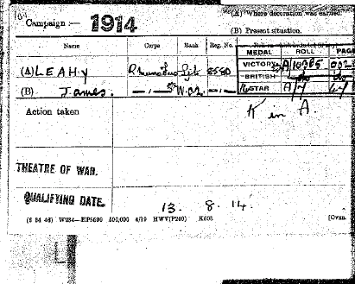

TYSON, THOMAS, SERGEANT, 2nd BATTALION - (CE 19/4/1916) – KILLED IN ACTION

SERGT. THOS. TYSON, Royal Munster Fusiliers, late of Great Britain street [Great William O Brien St.], Blackpool, Cork, died of wounds. Sergeant Tyson had been at the front almost since the start of engagements. He was wounded by a shell on 6th March, and died at the base hospital next day. He was 23 years of age. It was Sergt. Tyson when on leave last November who brought Sergt. Major Leahy’s presents to his father, Mr. Leahy, Glen View, Douglas.

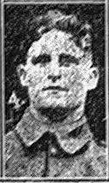

2nd Battalion Deployments Aug 1914.

August 1914 : In Aldershot. Part of 1st (Guards) Brigade, 1st Division.
14 September 1914 : Following heavy losses - notably at Etreux during the Retreat from Mons - transferred as Army Troops to Lines of Communication.
9 November 1914 : Transferred to 3rd Brigade, 1st Division.

SUMMARIES OF ACTIONS IN WHICH JAMES LEAHY FOUGHT.

ETREUX REARGUARD ACTION - 27TH AUGUST 1914.

The account below is from the pen of Lieutenant-Colonel H.S. Jervis M.C., late Commanding the 2nd Battalion Royal Munster Fusiliers. As a Captain, Jervis Commanded 'D' company during this action.

The 2nd Battalion arrived in France as a part of the 1st Infantry Brigade on August 13th. It proceeded from Havre by train to Le Nouvion, going into billets in the village of Boué, three miles east of Etreux, which was to be the scene of its first great action. After five days the Battalion marched up north to the Belgian frontier, doing a double march of over forty miles on the 22nd without undue fatigue, and remained in reserve on the 24th during the Battle of Mons. The retreat during the next three days was carried out in hot weather, the reservists especially being much galled by carrying the pack, to which many of them were quite unaccustomed. However, they "stuck it out" manfully, and the Battalion’s percentage of stragglers compared favourably with that of other units.

Up to the 26th, though continually within hearing of heavy firing, the Battalion had done no actual fighting, and it awaited somewhat impatiently the order to engage the enemy.

It is occasionally given to a brigade to hold up a whole division. A division may occasionally stop the advance of an army corps, but for one battalion of infantry, or, to be more exact, three companies, with the aid of a couple of field guns, to stein the advance of an entire army corps is probably an incident without parallel in modern warfare. Yet this was done on August 27th, 1914, by the 2nd Royal Munster Fusiliers.

The 1st Infantry Brigade, under the command of Brigadier-General Ivor Maxse, was covering the withdrawal of the 1st Army Corps. On the British right, i.e., to the east wards, was the 5th French Army. To the west stretched the whole British Expeditionary Force, at that date some five infantry divisions and a cavalry division. The Battle of Le Cateau bad been fought the day before, and the badly shattered 2nd Army Corps, under Smith-Dorrien, was withdrawing to the south. The German Army, in the full flood of its successful invasion of Northern France, was sweeping all before it. Nothing seemed to stop it or even check it. Fresh troops appeared like magic on the heels of our tired infantry, harassing the rearguards, cutting off small parties, getting in between different divisions, and generally impeding our retirement and involving the British Force in actions which threatened time after time to leave it in the air, cut off from its Allies. General Maxse determined that these mosquito tactics should not be allowed to interfere with the withdrawal of the 1st Army Corps, and he accordingly disposed of his rearguard in such depth as to keep a distance of over eight miles between the main body and the enemy. To effect this, he judiciously selected as rear party commander the Commanding Officer of the Munster's, giving him a free hand as to how to conduct his retirement. This officer was possessed of such a remarkable personality as to deserve special mention.

By name Paul Charrier, by rank a Major, he was mentally and physically one of the biggest men in the Army. Convinced twenty years ago that Britain would find herself sooner or later involved in European warfare on a large scale, he had concentrated his attention on preparing himself for the inevitable struggle. Having the advantage of French blood in his veins, he was equally at home on both sides of the English Channel.

He knew Northern France like the palm of his hand, spoke fluent French, and knew as much about the organization of the French Army as any British officer in France. His tactical ability and wide range of knowledge had already brought him into prominent notice at Aldershot.

After a somewhat tiring march on August 26th, the 1st Infantry Brigade found them selves billeted in and around the village of Fesmy, some seven miles south-east of Le Cateau. The next day the withdrawal was to be continued, and Major Charrier was allotted the task of covering the withdrawal of the remainder of the rearguard. He was given his own battalion, a troop of the 15th Hussars, and two guns of the 118th Battery, R.F.A., for this purpose. With the guns came Major A. R. Bayly, as gallant a gunner as ever stepped. Early in the morning of the 27th Major Charrier issued orders for the disposal of his small force, throwing out feelers to the east to get in touch with our Allies. Unlike most of France, the country here was much enclosed and movement, except by the roads, was a slow and laborious proceeding.

Charrier therefore concentrated on the defence of the roads by which any large force of the enemy must advance. Two companies were sent to an important road junction a mile to the north of Fesmy, and the greater part of a third company to cross-roads a mile to the south-east. The rearguard was thus facing, roughly, north-east, from which direction, as was afterwards ascertained, masses of the enemy were sweeping forward.

About 9 a.m. it was discovered that our Allies were beginning to withdraw from their positions farther east, and to move southwards in conformity with the general plan. In the meantime an entire German Army Corps (the 10th Reserve Army Corps) was approaching the positions held by the Munster's by two parallel routes. Both these routes were blocked, either directly or indirectly, by the Battalion. Shortly after 9 a.m. the action began with the appearance of the German cavalry, who advanced with great caution in front of their main columns. By this time our men had dug themselves in comfortably. and were prepared to make things hot for any intruder. However, the 17th Brunswick Hussars were no thrusters, and patiently awaited the arrival of reinforcements before investigating the position. These arrived an hour and a half later, and at about 11 a.m. a brisk action opened. The 2nd Guards’ Reserve Division, consisting of twelve battalions, advanced to the attack on both flanks of our position. To the south-east they penetrated into the village of Bergues, and after a sharp fight the company holding that flank, having inflicted heavy casualties on the enemy, withdrew to the south. On our other flank the enemy encountered a tougher proposition, for there he found 'B' and 'D' Companies of the Munster's strongly entrenched waiting for him. For half an hour he tried in vain to find a 'soft spot' in the defence, and then retired to await reinforcements. Mean while, 'D' company’s cooker had come up, and dinners were served out. Half the company was then separated from the remainder by a road, up which the enemy was firing heavily. The dinners were carried across this at the double by the company’s cooks, and the sight of these gallant fellows running across under their heavy loads with bent heads seemed irresistibly comic to the remainder of the company, who called out all sorts of facetious remarks. 'Don’t be emptying all the tay down your trowsies'; 'Come out of that, Micky; what are you stopping in the middle of the road for ?' etc. The cooks were highly incensed, and threatened reprisals, but these had to be postponed.

The sky now rapidly clouded over, and about noon a heavy thunderstorm broke over head, the rain coming down in sheets for a full half-hour. The enemy, who had been massing north-east of Fesmy for some time, now made a desperate effort to take the village. Pushing his attack home with great energy, and, making use of largely superior numbers, he penetrated into the village and established himself there. He even got as far as a couple of gun limbers drawn up on the roadside, and killed and dispersed the gunners and the horses. Things were looking so grave that a counter-attack was ordered by Captain Rawlinson, commanding 'C' company. This was delivered by a couple of platoons with a swing and dash that carried all before it. The village was cleared every German in it was killed or captured, and the enemy was driven back in disorder to the north-east. Elsewhere in the attack, delivered with the same energy, failed completely before the devastating fire of the Munster's, aided by their two machine guns and the two field guns which had been firing heavily for nearly an hour. The enemy, always cunning, tried the ruse of driving cattle in front of him to cover his advance, but this trick was soon discovered, and such a stream of lead turned on to him that he was sorry he tried the experiment, and hastily abandoned it. The machine-gun officer was Lieutenant C. F. Chute, one of the cheeriest and best of sportsmen.

Heavy German reinforcements had by now come up against 'B' and 'D' Companies on the left (northern) flank, and a furious fire was opened on these companies. The Munster's held their fire until the enemy arrived at short range, and then pumped lead into them. The rain was still pouring down, and, taking advantage of it and of the confusion caused by the sudden outburst of fire, both companies withdrew towards Battalion Headquarters north of Fesmy. Suspecting a trap, the enemy advanced cautiously to the evacuated positions, and by the time he realized the bird had flown a mile separated the combatants.

The action farther south was still raging when the two companies marched up very pleased with themselves, in spite of being soaked to the skin. By now it was after 1 p.m., and the withdrawal was proceeded with. The Battalion Headquarters were in a small estaminet at a cross-roads north of Fesmy; the din prodigious, rifle, machine-gun and artillery fire mingled with each other; the enemy added appreciably to the clatter. German wounded were brought in under cover by the Irish stretcher-bearers, groaning as they lay close by. The neighing of the excited gunner horses mingled with the shouted words of command as the guns were moved from one position to another.

In the midst of this babel of sounds Major Charrier conducted operations precisely in the same manner as he had a hundred times before in mimic battle at Caesar's Camp or Salisbury Plain—an admirable example of the soundness of the general lines on which our peace training was conducted. A lighter touch was added by one of the company cooks, who was chasing a stout young porker round a yard close by, and its yells could be plainly heard above the din of the battle.

Major Charrier now altered the order of battle, 'B' company under Captain G. N. Simms, M.V.O., becoming right flank guard (to the east), 'D' company left flank guard and rearguard. Our right, as we withdrew facing the enemy, was our most dangerous flank, and a better man than Captain Simms to meet such a situation could not be found. To the casual observer he would have been put down as a mere well-dressed man-about-town. But he was something more. He had a hobby, and that hobby was commanding a company. Indeed, it was claimed that he was the best company commander at Alder-shot before the war. He had the happy knack of training his subordinates to think and act for themselves, and before the end of the day this capacity was to be tested to the utmost.

By 2 p.m. the Germans attacking Fesmy village made up their minds that they were not going to put their heads into a wasps’ nest again without adequate precautions, and withdrew to await the arrival of their artillery. In the meantime the Munster's were silently evacuating their positions and marching through the village southwards. The two field guns preceded the move, and, taking up a position in the fields to the south of the village, again opened fire on the enemy. One company after another filed through the streets, leaving the unfortunate inhabitants behind them, until all were reported clear. At the last moment one section of 'D' company was reported missing. Back dashed an officer of the company under heavy fire through a farmyard into the fields beyond, found the section closely pressed by the enemy and reluctant to leave them without 'one more crack at them, sir'; he hustled them off, and rejoined the rearguard within ten minutes. The country here was rather more open, and the withdrawal continued slowly, "B" company to the east keeping the enemy at bay. The enemy now decided to play 'long bowls' with us, and showed great distaste for close quarters. By 5.30 p.m. the main body of the Munster's assembled at a cross-roads due east of a village named Oisy, through which lay our road southwards. Only 'B' company was missing. Messages were sent off eastwards by runners and bicycle ; the signaller got busy, but it was nearly an hour before the right flank guard rejoined the Battalion. This delay, as it was afterwards proved, was fatal to the Munster's, for all the time the French to the east were getting farther and farther distant, the German forces were getting closer and closer to our line of retreat, and our chances of escape were reaching vanishing point. The Brigadier’s orders for Charrier to retire never reached him, the orderly not being able to get through.

The battalion re-formed as a rear-guard, "B" and two platoons of 'A' company leading, followed by 'D', and 'C' bringing up the rear. While the battalion marched through Olsy, 'C' company, under Captain Rawlinson, held the outskirts of the village to keep off the enemy. Cavalry now appeared to the south — a somewhat ominous sign—but they were easily brushed aside by the accurate long-range fire of the Fusiliers’ machine-guns. The 6th Reserve Dragoons were no greater fire-eaters than their brethren from Brunswick. The 2nd Guards Division had suffered two sharp checks already, but, seeing the main body of the rearguard passing through Oisy, they made a bold plunge for the two entrances to the village. Out crashed the rifle fire again, spurts of flame burst from two harmless-looking houses at the east end of the village, a bridge over which the Germans were forced to come was quickly blocked with dead and dying. Efforts made to surround the village were checked by the deadly fire of the two platoons holding it. Brilliantly supporting each other, Lieutenant Deane Drake and Sergeant T. Foley held on until escape seemed impossible. From the high ground to the south the action was clearly visible. Major Charrier sent back to offer assistance. No, 'C' company could finish its job without outside help, and finish it they did. Gradually man after man was withdrawn, and after a final burst of fire the gallant Irishmen leaped to their feet and ran for it. Once more the rebuff administered took out all the sting of the German pursuit, and 'C' company rejoined the Battalion without further interference.

All this time the main German advance was steadily continuing. The 19th Reserve Infantry Division (i.e., the other half of the 10th Reserve Army Corps), under the command of General Von Barfeldt, was advancing on the left (east) of the attacking Germans, and making for Guise, twelve miles to our rear. Coming within two miles of the action of Fesmy, this division hesitated, and then halted. What was this heavy firing to the north? Should not the enemy be to the south? Rumours of a big British counter-attack were rife. Was this it? Obviously the situation demanded cautious handling. A careful reconnaissance was ordered, and the march southwards discontinued. Signs of fighting were observed close by; a couple of badly wounded Munster's were brought in. Heavy rifle and artillery fire continued at intervals during the afternoon. Patrols were pushed forward cautiously toward the village of Etreux to the west, and the 6th Reserve Dragoons reported a heavy column moving southwards through Oisy Then at last the German General, a "dug-out" long past his prime, was galvanized into activity, and pushed on with all speed to Etreux to crush this presumptuous British force under the famous German hammer.

Major Charrier must by now have realized that the situation was very grave, and he gave orders for the withdrawal to be carried out in a formation which was probably completely original. He appears to have anticipated a sudden flank attack, and ordered the battalion to move along the shallow ditches on both sides of the Oisy-Etreux high road, whilst the two Munster machine guns took up a position on the road, firing up the human corridor thus formed at the enemy to the north. While the stream of lead flowed north, the column steadily marched south, and such was the accuracy of the fire that once more the enemy’s pursuit was checked, and yet no misdirected round fell near our own men, who were within a few feet of the direct line. In this way the Munster's approached Etreux. Suddenly, a few hundred yards in front of the advance guard 'B' company) a party of men were seen to double across the road. Major Charrier, on perceiving this, ordered Captain Simms to brush aside this party of the enemy, which seemed to have taken refuge in a house on the west side of the road. He also ordered up the two field guns. The Munster's, ready as ever for a scrap, shook out and began working up on both sides of the road through orchards and fields.

The gunners whipped up their horses and galloped down the road. Crash ! A German shell burst amongst the leading gun team, killing and wounding most of the horses and men. A second shell bit a small farmhouse the guns were passing at the time, and a murderous short-range rifle fire was opened from the south. The last avenue of escape was dosed. The Munster's were cut off. While the few remaining gunners, under the gallant Major Bayly, made desperate efforts to get their guns into action, Major Charrier went forward to the post of danger to organize an attack on the enemy holding the outskirts of the village, including a loopholed house on the side of the road. Passing the gunners, he called out, "Come on, Bayly, and put a round into that house. We’ll soon boost them out of that." As he went, his gigantic figure was rendered especially conspicuous by the khaki-coloured helmet with the green and white hackle of Munster, which he always wore. On still with a handful of officers and men, along the road to within a hundred yards of the loopholed house. Man after man dropped; the last unwounded gunner met his fate struggling to carry an 18-pounder shell to the gun, standing on the road, surrounded by a small heap of huddled-up bodies. The devoted group pushed on and gradually melted away. Back came Paul Charrier, still unwounded, to make yet one more effort. 'C' company was coming up from Oisy. Both Captain Rawlinson and Lieutenant Deane Drake were wounded; both gamely carried on. The company was brought up in support, leaving 'D' company in reserve, lining the ditches under fire from all points of the compass, but unable to reply to it. Supported by Captain Douglas Wise, the best of Adjutants, Lieutenant O’Malley and Lieutenant Moseley, the Commanding Officer led another dashing attack up the road. Once more the hail of lead was met, and one after another fell. Heedless of this, the remainder pushed on, until Captain Wise actually got up to the loopholed house, under cover of which the enemy was firing unceasingly, and, taking a rifle from one of the dead lying near, he fired through the loophole until knocked senseless by a blow on the head.

Again the attack failed; but Major Charrier was not the man to give in while hope still existed. Once more he collected a handful of men, and though now suffering from a severe wound, he again returned to the charge with a determination beyond all praise. Alas! this time was the last. Providence was tempted once too often, and the great soldier fell, riddled with bullets, Lieutenant Moseley being stunned by a bullet a few moments later. Dusk was now approaching, and it became difficult to distinguish friend from foe. A farmhouse near by caught fire, and its lurid flames added to the wildness of the picture.

While the attacks just described were proceeding, company Sergeant-Major McEvoy, a fine old soldier, finding his company losing heavily in officers and men, ran back to get reinforcements, and returned down the bullet-swept road shouting, "Come on, boys; the Irish never lost a Friday’s battle yet." His officers, exposed to a terrible fire fell one by one, until the whole five made "the great sacrifice," headed by their dashing commander, Captain Simms.

The last phase was developing faster than it takes to tell. Perceiving the gravity of the situation, and without waiting for orders, Captain Jervis took the main portion of 'D' company over into the fields to the east of the road, in a desperate endeavour to break through the enemy drawn up due south, by prolonging the Irish attack eastwards. At first all went well; a dip in the ground favoured the movement; the company, moving in alternate waves, steadily advanced, firing at each halt. The farthest point reached by the other companies was reached and passed. Was this the weak spot at last? The company passed through an orchard, across a couple of fields, and discovered a thick hedge bordering the last field between it and the village. This was in reality lining the top of a steep cutting, at the foot of which lay the railway line. From the hedge, which provided admirable shelter to the enemy, a heavy fire was opened. The advance still continued methodically until the company approached to within 70 yards of the position. Then a sharp rifle duel ensued between the opposing sides, followed by a shrill whistle and the order to charge. Up got the Irish and dashed forward with a cheer, bayonets fixed. The enemy’s fire redoubled in vigour and took heavy toll of the company. Lieutenant Phayre fell cheering at the head of his men. Huge gaps appeared in the on-rushing wave; the survivors, reduced to a few groups, struggled forward a few yards, only to fall in their turn. One officer reached the hedge alive. Drawing his revolver, he accounted for six of his opponents in rapid succession; but, alas ! the last desperate effort to cut through the enemy had failed.

Many of the survivors of the various attacks fell back to the orchard near the main road. Captain C. R. Hall, of 'A' company, took command. Seeing the enemy pressing forward on the east, he ordered a charge. A small party of heroes sallied forth, and though the enemy were fifty to our one, they fell back, afraid to meet our cold steel. The little party then returned to the orchard. The enemy now formed a complete ring round the remnants of the battalion. Nine officers had been killed, and Captain Hall was shortly afterwards severely wounded. The command devolved on Lieutenant Gower. For the first time since early morning the machine guns were silent. Lieutenant Chute, having fought his guns to the last, was killed. Sergeant Johnson immediately assumed command, and continued firing until the last cartridge was used; then he took his beloved guns in turn, and smashed them to pieces. Ammunition was nearly exhausted, but the survivors, husbanding every round, lined the four sides of the orchard and kept the enemy at a distance. Lieutenant Moseley had recovered consciousness, and fought up to the last. It was now growing dark, and the situation was at length regretfully recognized as hopeless. Sounds of the expected reinforcements were listened for in vain, and our cup of bitterness was full.

At 9.15 p.m. on the 27th, a bare 240 men, including many wounded, staggered to their feet, with four unwounded officers. This was the remnant of the splendid battalion which had set out so full of hope that same morning. How long ago it seemed.

On the 28th the Germans allowed a party from the prisoners of war to collect and bury their dead in what is now the Etreux Memorial Cemetery.
To do the German justice, he recognized and admitted the desperate bravery of his enemy. But when he ascertained the paltry numbers opposed to him, he was furious. The General blamed his subordinates. The battalion commanders said nothing, but thought volumes. The main body of the British Army had vanished to the south, and were by now twelve miles away. The famous German hammer had crashed on to the anvil and had crushed what ?, a butterfly, a battalion, a mere detachment; and a whole German army corps had been delayed. It surely was a fitting opportunity for the series of guttural expletives roared out into the night by the enraged Teuton. And this paltry detachment had, by their ill-advised obstinacy, caused great and unnecessary loss to the Fatherland. No less than 1,500 German wounded were assembled in the village of Etreux next day. It is not known how many casualties occurred earlier in the day in the other villages, but the number must have been considerable. So ended the action of August 27th, 1914.

When the last shot was fired a space of twelve miles separated our 1st Army Corps from the 10th German Reserve Army Corps; valuable breathing time and space had been procured, and the next morning the Germans were fourteen hours behind their program. A few more such victories, and the enemy would have scarcely been in a condition to reach the Aisne. much less the Marne. That splendid soldier Paul Charrier, with some 110 of the Musters, lies buried in a peaceful orchard near Etreux, the scene of their exploit. May history accord to these heroes the merit they so richly deserve !

On the proposal being put forward by the 2nd Battalion to erect a Regimental Memorial at Etreux, the following letter was received from the Secretary, Battle Exploits Memorial Committee,

2ND ROYAL MUNSTER FUSILIERS AT ETREUX.

The action is likely to become the classical example of the performance of its functions by a rear-guard. The Battalion not only held up the attack of a strong hostile force in its original position, thereby securing the unmolested withdrawal of its Division, but in retiring drew on to itself the attacks of very superior numbers of the enemy. It was finally cut off at Etreux by five or six times its numbers, but held out for several hours, the remnant only surrendering when their ammunition was practically exhausted and only a small number of men remained unhurt. The survivors were warmly congratulated by the Germans on the fine fight they had made. No other claim to a memorial near Etreux is likely to be advanced—certainly nothing which would not take second place to the Munster's.

(Sgd.) C. T. Atkinson
7/6/1919. Historical Section, C.I.D.

Battles at Rue du Bois / Aubers Ridge 9th May 1915

...It is a remarkable fact that the attack, prepared with so much secrecy, was known in detail to the enemy...

Lieutenant-Colonel H.S. Jervis, M.C.

After the terrible grueling that the 2nd Munster's received at Festubert on December 22nd, 1914, a short period of comparative quiet ensued. When one writes of quiet, it must be remembered that it is a comparative term. There are many who prefer the stress of fighting to the eternal labour of building up and holding trench lines half under water, combining the worst form of amphibious warfare with training of the most intensive form. The War Diary of that period repeats with wearying monotony -

Trenches very bad; The support-line untenable through flooding ; or Trenches in a deplorable condition.

Nothing but unremitting toil made them habitable at all. Every day took its toll of brave men, a stray shot here, an unlucky shell burst there, ever the watchful sniper ready to punish careless exposure whenever it occurred.

During the second half of January the 2nd Munster's were continually engaged repelling the German attacks which culminated in the Kaiser’s birthday attack of January 25th. Fighting of the bitterest description developed, and the line held by the division was broken at many points. But the 2nd battalion Munster's in the front line lost not a yard of trench. The Battalion was holding a sector within two miles of their old battle ground at Givenchy, just north of La Bassée Canal.

By the beginning of May the 2nd Munster's had been brought up in strength to 26 officers and nearly 700 non-commissioned officers and men. Command of the Battalion had been taken over by Lieutenant-Colonel V. G. H. Rickard.

The blessing of 2nd Munsters in the Rue De Bois, prior to their attack on Aubers Ridge, May 1915

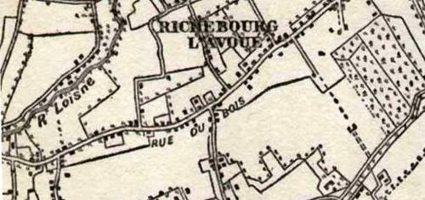

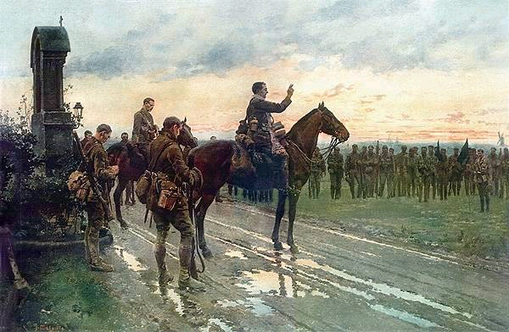

The priest is Father Gleeson who gave the Last Rites to James at Loos.

"On the evening of 8th May 1915, under command of Lt-Col. V.G.H. Rickard, 2nd Munsters once again marched towards the Front. At a French wayside shrine, Rickard halted the Battalion and formed a hollow square before it. On three sides were the rifle companies, and facing them on horseback were Col. Rickard, his adjutant, Capt. Filgate and the Chaplain, Father Gleeson. Gun flashes added to the semi-light of a spring evening; gunfire and shell explosions reminded all of the ordeal to come. All bared their heads and the light breeze ruffled hair and caused to flutter the green company standards. Father Gleeson's stole made a splash of soft colour. The chaplain raised his right hand and intoned general absolution and all sang the Te Deum. Then, to the barked command of RSM Ring, the march resumed towards the sound of the guns."

Munsters lost 19 officers and 374 men that day on Aubers Ridge - many of them to their own artillery.

The Battle of Loos. 25th to 30th September 1915.

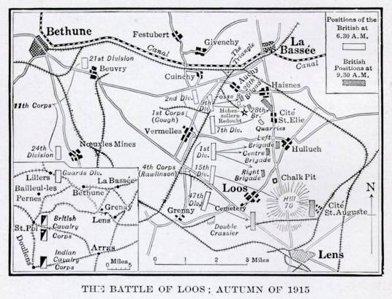

2nd Munsters were part of 3 Brigade 1st Division 4th Corps.
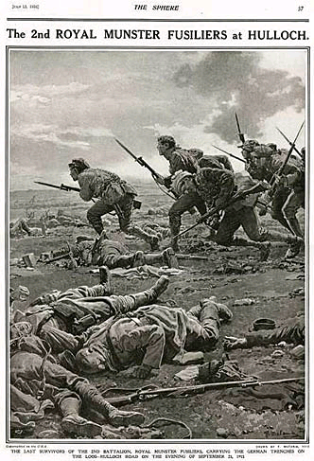

The artist's impression of the remaining survivors of the 2nd battalion Munster Fusiliers in the battle for Loos, seen overrunning the Germans on the Loos -Hulluch road. Illustration left from the history of the Munster Fusiliers, the illustration also appeared in 'The Sphere', dated I think July 15 1916.

On the morning of the 25th September 1915, the Loos battle commenced with a heavy bombardment and release of gas by the British, gas cylinders were used for the first time.

The 2nd Battalion was in support of I, IV Corps, the release of gas was not entirely successful, falling short of German trenches but catching British troops in their advance.

The 2nd Battalion moved up to the support trenches evacuated by the assaulting brigade, however their way was blocked by those soldiers who were gassed as they staggered back to field dressing stations for medical attention.

Major Gorham, observing the congestion with concern, ordered the Battalion to leave the trench and proceed over open ground to their objective, however they came under heavy machine gun fire and suffered numerous casualties.

By September 30th the Battle of Loos was over to all intents and purposes, but again the 2nd Battalion found it's ranks reduced to under 350 men and by the end of October in subsidiary fighting this number was further reduced to about 250.

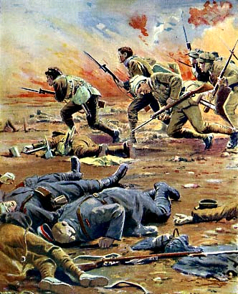

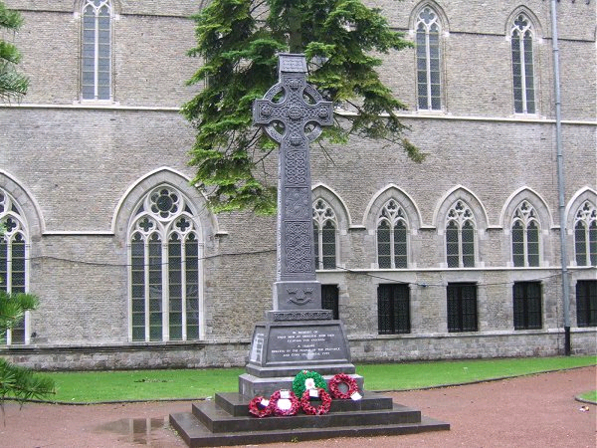

"In memory of those men of Munster who died fighting for freedom. A tribute erected by the people of the province and Cork its capital city". This beautiful and fitting memorial stands in the shadow of the rebuilt Cathedral in Ypres.

ANOTHER DESCRIPTION OF LOOS & JAMES’S DEATH.

By Mrs. Victor Rickard.

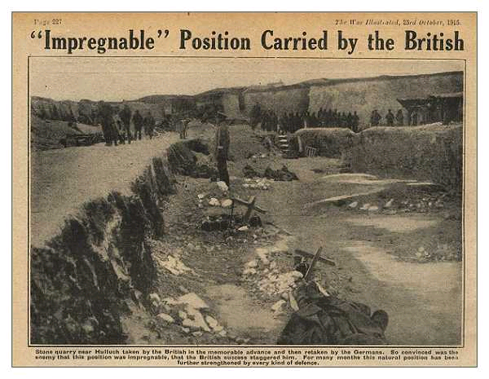

September 25, 1915

Below the chateau of Vaudricourt there is a wood which closes it around with a sense of security belonging to fir woods, and the zone of pines is dense and fragrant.

On the night of September 23, 1915, the Royal Munster Fusiliers marched from the little village of Philosophe and bivouacked in the Vaudricourt domain. The battalion was on the march again, and that dim, cloudy night they trooped in under the shelter and lighted their camp fires.

The whole effect was mysterious and unreal as things seen in dreams; the columns of luminous smoke soared upwards, illuminating the low strong branches of the trees, and around the fires the men lay huddled in their great-coats, grouped within the circles of flickering light.

Just as the fires were dying down into blackness a little incident that memory dwells upon changed the Vaudricourt woods into an undying picture for those who saw it. One of the men stretched out his arm and placed a lighted candle on a branch just over his head, and as though this simple act appealed to the memories and imaginations of his comrades, in a moment the pine woods of Vaudricourt became transformed into a forest of Christmas trees. One after another the tiny flames appeared, and burned like a hundred little glittering shrines. God knows what memories of childhood and things that were far enough away from war it recalled to the hearts of these men.

Yet the memory of the clouded night, the whisper of the wind in the trees, and the woods of Vaudricourt, bright with the soldiers' candles, comes like a gleam across the vast darkness and lights again the faces of the war-worn battalion once more on its way to the fighting line.

On September 24 the Munsters took up their position close to La Routoire Farm. Beyond these trenches the Germans occupied a long, sweeping ridge of down land; a space of quiet scenery spread out to the horizon like a calm sea. On the German side were Auchy, Hulluch, and Loos, and on the British Cambrin, Vermelle, Philosophe, and Mazingarbe, and between them the desolate ground from which living things are fenced and barred out. The trenches divided the two main roads at right angles, and the Hulluch road played an important part in subsequent operations. Here and there over the grass piles of slag stood out like stubborn towers, black and desolate as some minor, haunting fragment of an evil dream. They masked the mines, and were treacherous, cruel defences on a poor, wasted land.

The weather was gloriously fine, and under the heavy bombardment of the British guns the whole sky line seemed to be in eruption. Huge masses of chalk-dust and smoke lifted hundreds of feet into the air, and rolled slowly away like a drowsy cloud trailing near the ground and reluctant to depart from this "best of all possible worlds."

In the grey light of the morning of September 25 the British guns opened a furious fire, joined by the rattle of rifle and machine guns. Without fuss or disorder the Munsters awaited the moment when they should face a pouring stream of bullets and charge into the teeth of the storm.

Led by Major Considine, the Munsters pushed up the winding trenches to the front line, exchanging a word or two as they went, and relying, as all men do in time of crisis, upon those unexplained resources that stand for all that is best in a soldier. When they reached the front line the leading company was blocked, for the trenches were full of men, with their faces coloured an ashen blue and the buttons and badges on their coats turned green. Some were dead and others unconscious, for they were the helpless victims of gas fumes.

When the Munsters charged over the parapet the Hulluch road was alive with troops racing towards the German trenches, but to the front all was quiet, and a number of khaki figures in blue gas helmets lay very still out over the grass towards the German lines, having so encountered that "last and greatest of all fine sights" in the cold dimness of half oblivion.

The fire from the enemy's guns increased as the Munsters advanced with a yell, and the wire ahead of them was apparently unbroken.

Leading "A" Company, Major Considine fell in the advance, and as he sank down Sergeant-Major Jim Leahy rushed forward to carry him into safety. He, too, was hit through the heart by a German bullet, and when he fell the advancing Munsters cheered him as they raced ahead, carrying with them the memory of the two men who had fallen so gallantly, into their fierce charge. Both Major Considine and Sergeant Leahy are buried on the battlefield almost where they fell, 800 yards west of Vermelles.

Up the long-deserted, grass-grown Hulluch road six batteries came at a gallop, wheeling boldly across the open under heavy fire, the Munsters, in conjunction with the brigade, following at a run. Great volcanoes of black smoke shot up immediately as the bombers worked down the German trenches. Lieutenant Denis Conran with six of his company occupied a support trench crowded with German troops, and for forty-eight hours held this small salient of the advance, waging a steady war with unwavering determination and grit. The enemy were all around this small handful, and from where they fought they could see the village of Hulluch being knocked to pieces like a card-house, and again on the right the shell-torn havoc of the advance to Loos, the chalk pit, and Hill 70. The larger stride had been taken at last, and the men in their gas helmets with their five days' growth of beard looked strange and almost oriental as they advanced, receded, and again advanced as the deadly conflict rolled onwards.

Towards evening the weather turned bitterly cold and heavy rain began to fall. The smell of poison gas, shell fumes, and blood became almost overpowering. Among the torn bodies the flotsam of war lay unheeded in the mud. Innumerable blankets, rifles, caps, belts, and bloodstained dressings told that a memory was all that was left to many of those who had been alive and glad a few hours before, and everywhere there were dead, dying, and wounded men, and all the helpless misery of battle.

The troops charged again, and the remnants of the Munsters raised another cheer and rallied for the last rush, and then the strain ended as you may see men pulled suddenly over at a tug-of-war. Four columns of German soldiers filed out of the trenches, holding their hands above their heads.

The road from Loos to Hulluch was clear at a cost of 1,000,000 shells and 50,000 men. A right of way was established at a price that no one can ever tell, since broken lives and hearts are not entered into any known roll of honour, and this right of way was made good by the simple valour and indomitable constancy of the ordinary man.

For them there is no return, for those who waited for them no more reason to cross the days off the calendar; stillness has intervened — the stillness that marks the passing of the mortal to immortality. Tears are useless, broken hearts useless; life will not alter because of these things. The days go on, and we with them; those who have gone have "bought eternity with a little hour, and are not dead."

And the road is now clear from Loos to Hulluch.

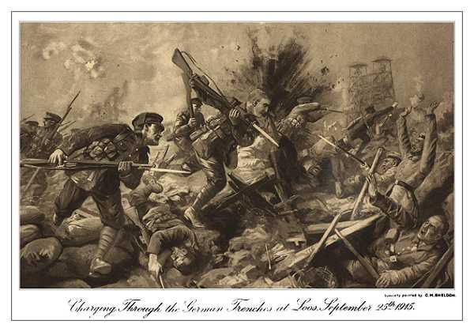

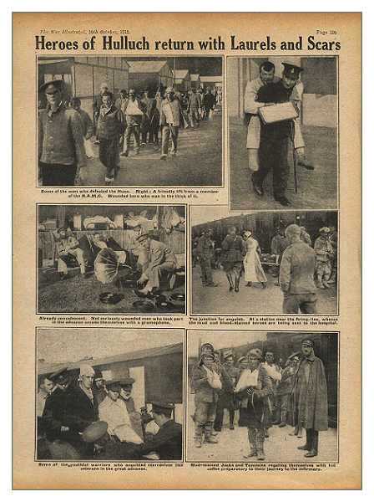

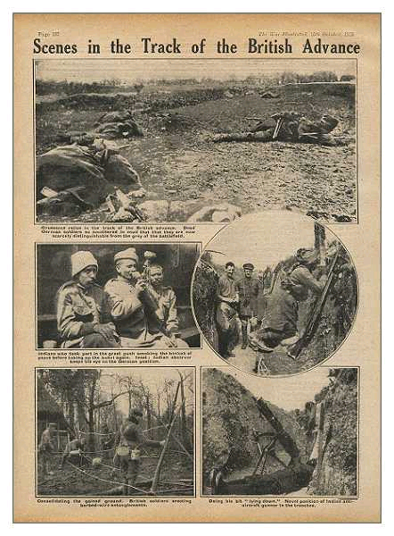

References:

- CE is the Cork Examiner. (Now Irish Examiner.)
- 'The 2nd Munsters in France,' by Captain Jervis.
Available reprinted by Schull Books.
http://www.schullbooks.net/
- 'History of the Royal Munster Fusiliers,' by Captain McCance.

Thanks are due to:

Jean Prendergast of Cork.

The Great War Forum. http://1914-1918.invisionzone.com/forums/index.php?
The National Archives, Kew.
Commonwealth War Graves Commission.
http://www.cwgc.org/search/casualty_details.aspx?casualty=527529

Footnote:

Jane Ellis’s great uncle Thomas Mair of the Gordon Highlanders was killed on the same day in the same action. He was in the 15th Highland Division on the right flank of the Munsters.

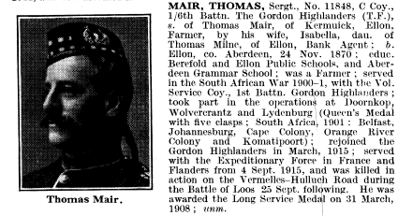

A Coy 2nd Bn Royal Munster Fusiliers. Tidworth 1912

( Sgt J. Leahy seated 4th from left.)

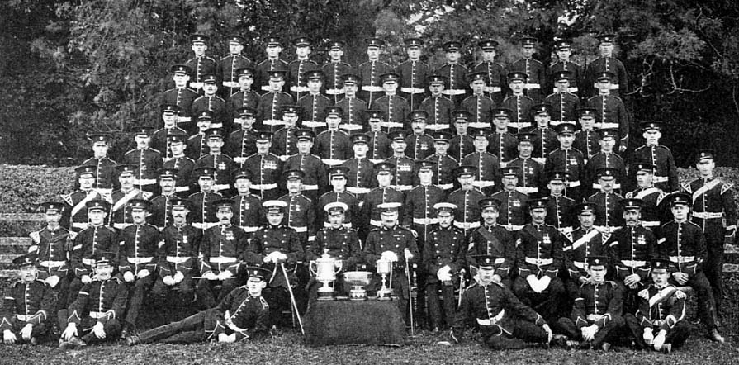

Sgts Mess, Tidworth 1912.



